

Maths Calculation Policy
2024

Written by Sarah Laughlin

At Silver End Academy, we believe that children should be introduce to the processes of calculation through practical, oral and mental activities.
As children begin to understand the underlying ideas they develop ways of recording to support their thinking and calculation methods, use particular methods that apply to special cases, and learn to interpret and use the signs and symbols involved.
It is important that we support all pupils in developing their mathematical thinking, both in order to improve the way in which they learn, as well as the learning itself. Good questioning can be used to develop pupils’ ability to compare, modify and generalise, all building a deeper understanding of mathematics.

Teaching for Mastery
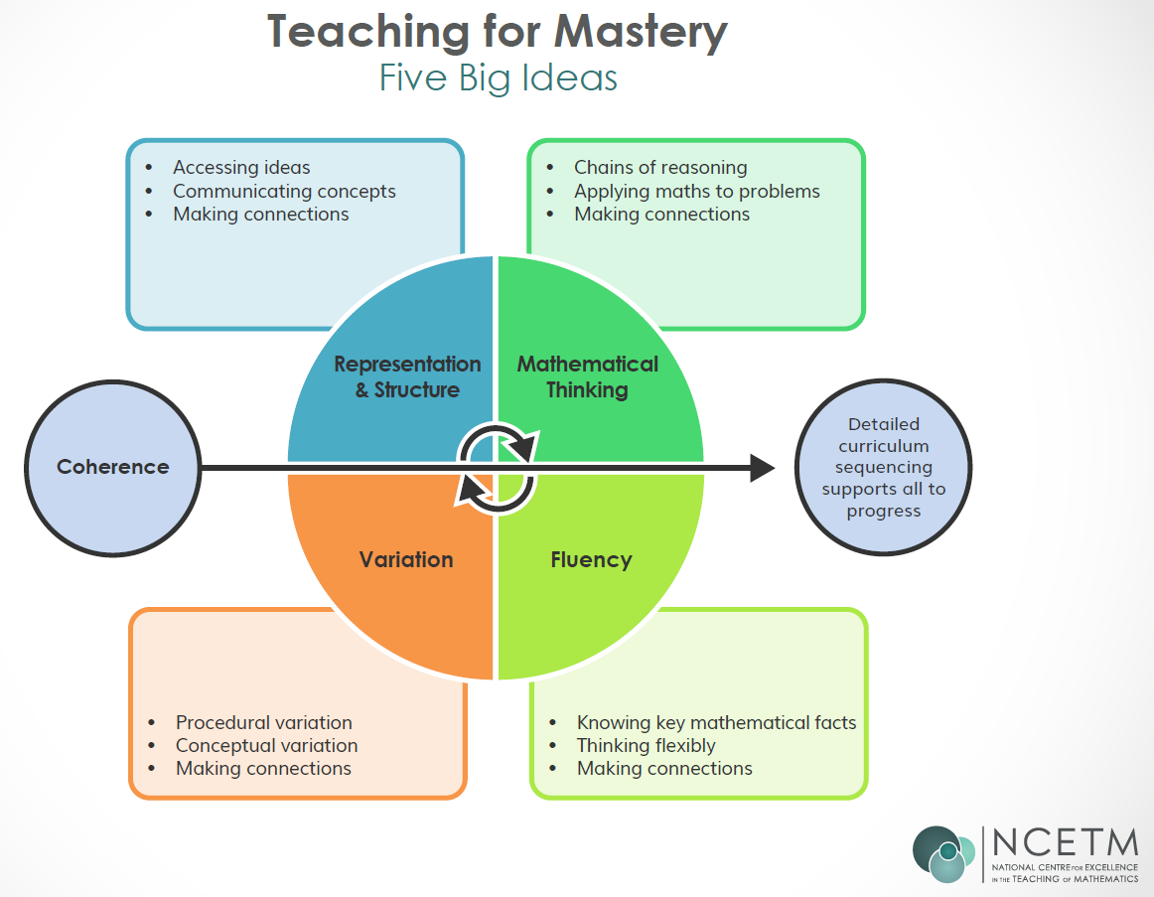
Our Lesson Structure

- I do
Explicit teacher model and instruction
During the 'I do' phase of the lesson, teachers tell students what they need to know and show them how to do what they need to do. Teachers, therefore, are, at this stage, involved in informing, explaining, modelling, and providing examples.
- We do
This stage of learning involves working on tasks together. Teachers and students use worked examples with some elements missing, to help students become more confident with the new learning.
- You do
This phase of the lesson involves students using what they have been taught. It can involve practising skills that they have just been shown. This can involve asking students to recreate what you have asked them to do. It can also involve simply answering practice questions and completing all the steps themselves.

CPA Approach
At Silver End Academy we also use the CPA approach to our lessons. CPA stands for Concrete -> Pictorial -> Abstract.
C
- Concrete = maths concept is modelled with concrete materials
P
- Pictorial= maths concept is modelled with representational examples- such as drawings
A
- Abstract = Maths concept is modelled with numbers and symbols.
Oracy & Vocabulary Skills
What is oracy? Oracy is to speaking what numeracy is to maths. It's the ability to communicate verbally and structure your thoughts so that they make sense to other people.
- Communicate and develop mathematical language using a carefully sequenced, structured approach to introducing and reinforcing mathematical vocabulary throughout maths lessons, so pupils have the opportunity to work with word problems from the beginning of their learning. This is achieved through:
  - Sharing the key vocabulary at the beginning of every lesson in the ‘Discover’ section and insisting on its use throughout
  - Modelling clear sentence structures and expecting pupils to respond using a full sentence
  - Maths talk, allowing pupils to discuss their thinking and reasoning of the concepts being presented using stem sentences
  - Think mathematically and build resilience to the challenges they face within and across the subject by having the opportunity to:
  - Explore, wonder, question and conjecture- feeling safe to make mistakes and learn from these through exploring their own understanding and application of maths
  - Compare, classify, sort- using clear verbal reasoning as to how or why they have classified their objects- again with the confidence to explain and discuss their thoughts with their peers and their teachers
  - Experiment, play with possibilities, vary an aspect and see what happens- similar to how children learn to play with language in literacy- explore what happens when the changes are made, are there patterns that appear- if so what is happening and from this can they predict what will happen as the sequences continue?
  - Make theories and predictions and act purposefully to see what happens- making generalisations and exploring them both independently, with peers and with adults alike.

This policy contains the key pencil and paper procedures that will be taught within our school alongside practical resources. It has been written to ensure consistency and progression throughout the school and reflects a whole school agreement.
Representations you will see:
Part-Whole model & Bar model
The part whole model is a pictorial representation that shows the relationship between a whole and its parts. While usually constructed with just two parts, a whole number can be partitioned (split) into as many component parts as a person may choose. The bar model method is a way to represent the underlying structures of mathematical problems to aid problem solving.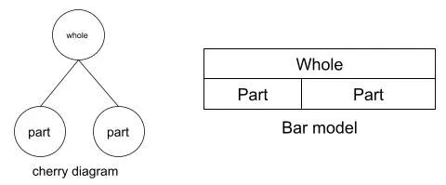

Within this document you will see the progression within each element of mathematics from EYFS up to Year 6, including the continuation of key vocabulary within each year group. The new vocabulary for each year group will be highlighted in bold

Ready to Progress Criteria
https://assets.publishing.service.gov.uk/government/uploads/system/uploads/attachment_data/file/1017683/Maths_guidance_KS_1_and_2.pdf

Resource Links
Oak National Academy: https://www.thenational.academy/
White Rose: https://whiteroseeducation.com/resources
Grammasaurus: https://grammarsaurus.co.uk/portal/
NCETM: https://www.ncetm.org.uk/teaching-for-mastery/mastery-materials/primary-mastery-professional-development/
Maths Salamander: https://www.math-salamanders.com/
NCETM-Teaching for Mastery: https://www.ncetm.org.uk/teaching-for-mastery/mastery-materials/

Addition


EYFS
Children will engage in a wide variety of songs, rhymes, games and activities to build their awareness of number.
They will begin to relate addition to combining two groups of objects, first by counting all and then by counting on from the largest number.
In practical activities and through discussion they will begin to use the vocabulary involved in addition. We use a range of representations using concrete and pictorial methods to build the abstract concepts.
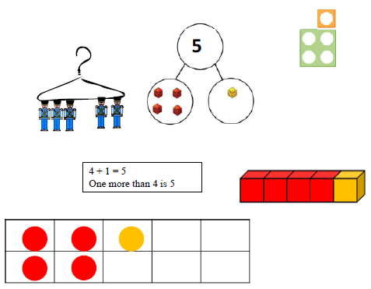
Key Vocabulary
Add, more, plus, make, together, altogether

Key skills for addition at EYFS
- Automatically recall (without reference to rhymes, counting or other aids) number bonds up to 5 (including subtraction facts) and some number bonds to 10, including double facts.
- Children count reliably with numbers from 1 to 20
- Place numbers to 20 in order and say which number is one more than a given number.
- Using quantities and objects, they add two single-digit numbers
- Count on or back to find the answer

Year 1
NB: Ensure that children are confident with the methods outlined in the previous stage’s guidance before moving on.
Children will continue to practise counting on from any number e.g. ‘Put four in your head and count on three.’
Initially use a number line or bead strings to count on for addition, counting on from the largest number: 4 + 3 = 7
Children should:
- have access to a range of equipment eg. Number lines, counting apparatus, Numicon, 100, squares, bead strings etc
- be shown numbers in a range of contexts
- Read and write number sentences using the = and + signs
- Interpret number sentences including missing number problems eg. 5 + □ = 7
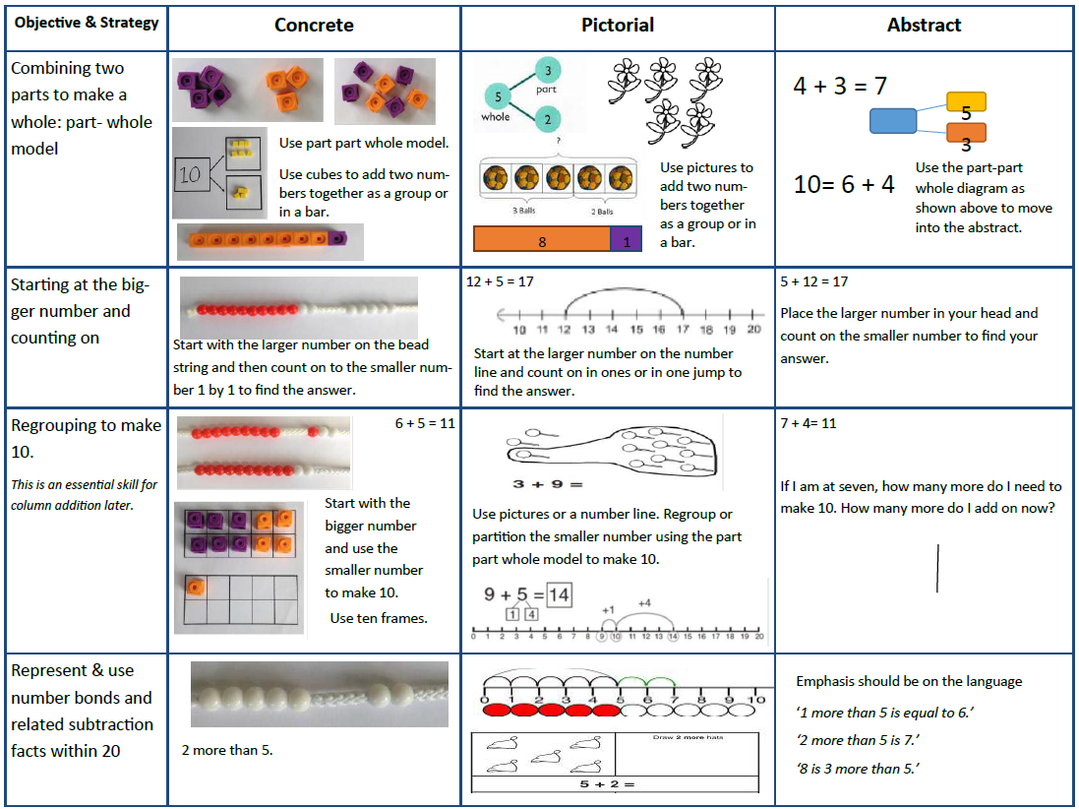
Key Vocabulary
Add, more, plus, and, make, altogether, equal to, equals, double, most, count on, number line

National Curriculum recquirements
- Read, write and interpret mathematical statements involving addition (+), and equals (=) signs
- Represent and use number bonds and related facts within 20
- Add one-digit numbers to 20, including zero
- Solve one-step problems that involve addition, using concrete objects and pictorial representations

Year 2
Ensure that children are confident with the methods outlined in the previous stage’s guidance
before moving on.
The use of practical manipulatives will still be used to add three one digit numbers, a 2 digit + 1 digit number and two 2 digit numbers.
Children move to more formal recording using the partitioning method, setting out as follows:
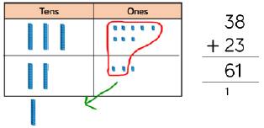
This needs to be practiced in a concrete fashion, moving to pictorial before abstract representations are used.
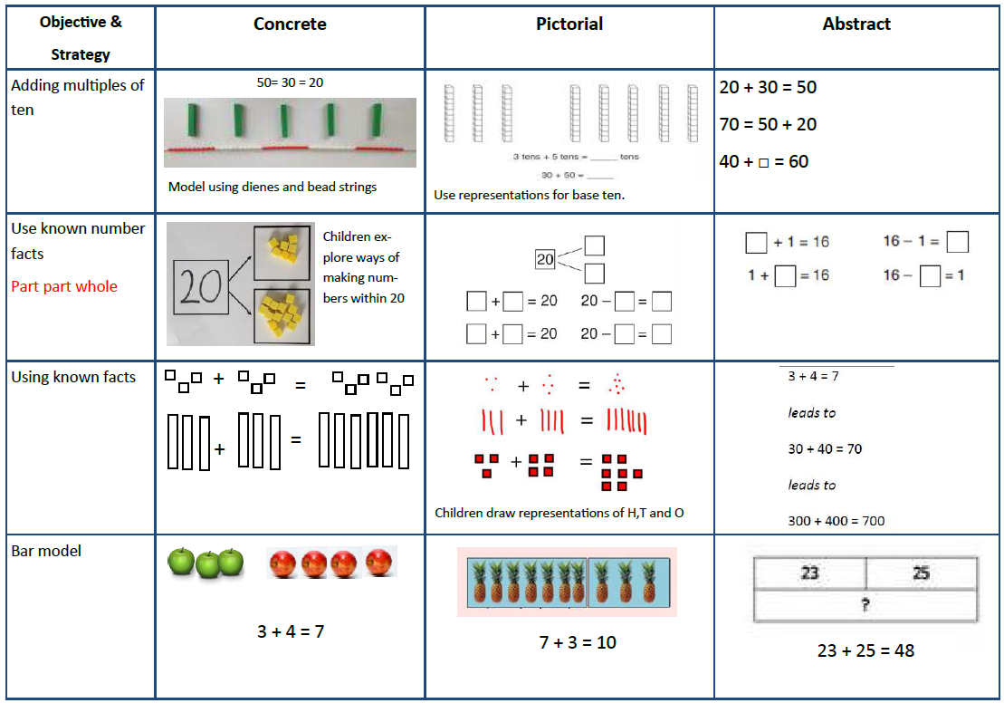
Key Vocabulary
Add, more, plus, and, make, altogether, total, equal to, equals, double, most, count on, number line, sum, tens (T), ones (O), partition, column

National Curriculum requirements
- Solve problems with addition
    - Using concrete objects and pictorial representations, including those involving numbers, quantities and measures
- Recall and use addition and subtraction facts to 20 fluently, and derive and use related facts up to 100
- Add and subtract numbers using concrete objects, pictorial representations including mentally
- Show that addition of two numbers can be done in any order (commutative)
- Recognise and use the inverse relationship between addition and subtraction- using this to check calculations and solve missing number problems.
Year 3
When they are ready, children move on to the expanded written method supported by practical activities. We know children are ready for this method when they:
- Know addition and subtraction facts to 20
- They understand place value and can partition numbers

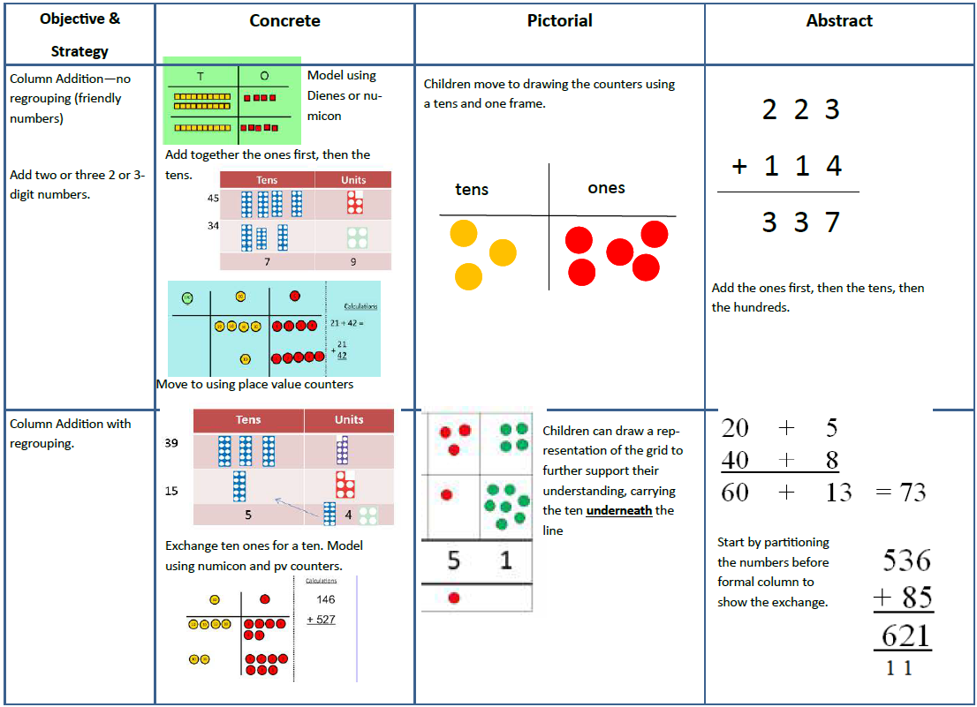
Key Vocabulary
Add, more, plus, and, make, altogether, total, equal to, equals, double, most, count on, number line, sum, tens (T), ones (O), partition, addition, column, increase

Nation Curriculum requirements:
- Add and subtract numbers mentally, including:
    - a three-digit number and ones
    - a three-digit number and tens
    - a three-digit number and hundreds
- add and subtract numbers with up to three digits, using formal written methods of column addition and subtraction
- estimate the answer to a calculation and use inverse operations to check answers
- solve problems, including missing number problems, using number facts, place value and more complex addition and subtraction.

Year 4
Children continue to use the column method, addition the ones first, and carrying underneath the calculation where a new ten is formed. Their additions will include money and measures in meaningful contexts. Just like previous year groups, children will explore addition within the column method using mathematical ecquipment such as base ten and place value counters. They see the addition method in a variety of ways, including part-part whole models, bar models and the column method.
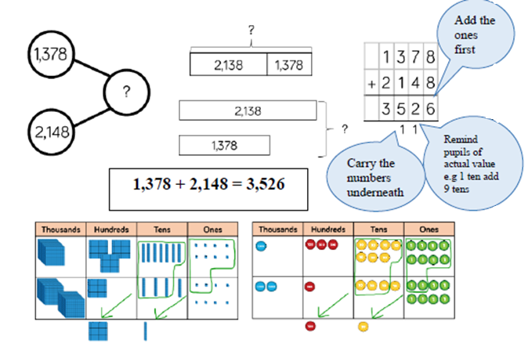
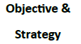
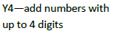 | Children continue to use base ten or place value counters to add, exchanging ten ones for a ten and ten tens for a hundred and ten hundreds for a thousand. | Draw representations using place value grid. | Continue from previous work to carry  hundreds as well as tens.  Relate to money and measures.

Key Vocabulary
Add, more, plus, and, make, altogether, total, equal to, equals, double, most, count on, number line, sum, tens (T), ones (O), partition, addition, column, increase, thousands (Th), hundreds (H), digits, inverse, bridging ten

National curriculum requirements:
- add numbers with up to 4 digits, using the formal written methods of column addition and subtraction
- where appropriate estimate and use inverse operations to check answers to a calculation
- solve addition two-step problems in contexts, deciding which operations and methods to use and why.

Year 5
At this stage, children add numbers with more than 4 digits including money, measures and decimals with different numbers of decimal places. Place value counters on a grid are the most effective manipulative when adding decimals with 1,2 and then 3 decimal places.
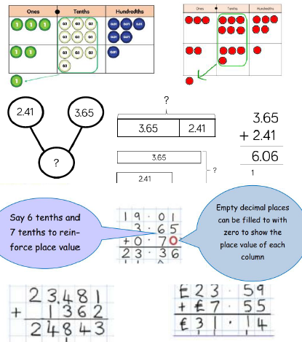
Y5—add numbers with  more than 4 digits.  Add decimals with 2 decimal  places, including  money. | 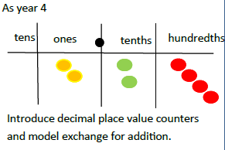
Key vocabulary
Add, more, plus, and, make, altogether, total, equal to, equals, doubles, most, count on, number line, sum, tens (T), ones (O), partition, addition, column, increase, carry, thousands(Th), hundreds (H), digits, inverse, decimal places, decimal points, tenths(t), hundredths(h), thousandths (th)

National Curriculum requirements:
- add whole numbers with more than 4 digits, including using formal written methods
- add numbers mentally with increasingly large numbers
- Use rounding to check answers to calculations and determine, in the context of a problem, levels of accuracy
- Solve addition multi-step problems in contexts, deciding which operations and methods to use and why
Year 6
In year 6, children should be able to add several numbers of increasing complexity. The written method should be efficiently applied to multi-step problems and the adding of numbers with varying amounts of decimals should be mastered.
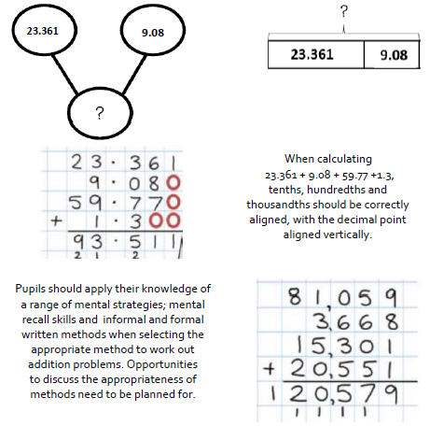
Y6—add several numbers  of increasing complexity  Including adding money,  measure and decimals  with different numbers  of decimal points. | As Year 5 | As year 5 | Insert zeros (0) for place holders
Key Vocabulary
Add, more, plus, and, make, altogether, total, equal to, equals, double, most, count on, number line, sum, tens (T), ones (O) partition, addition, additive, column, bridging ten, bridging hundreds, increase, carry, expanded, thousands (Th), Hundreds (H) digits, inverse, decimal places, decimal point, tenths (t), hundredths (h), thousandths (th)
National curriculum requirements:
- Use their knowledge of the order of operations to carry out calculations involving the four operations
- Solve addition and subtraction multi-step problems in contexts, deciding which operations and methods to use and why

Subtraction

EYFS
Children will engage in a variety of counting songs, rhymes and practical activities.
In practical activities and through discussion, they will begin to use the vocabulary associated with subtraction.
They will find one less than a given number to 20.
They will begin to relate subtraction to ‘taking away’ using objects to count ‘how many are left’ after some have been taken away.
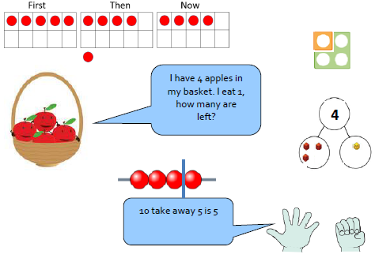
Key Vocabulary
Lots, groups of

Key skills for subtraction at EYFS
- Automatically recall (without reference to rhymes, counting or other aids) number bonds up to 5 (including subtraction facts) and some number bonds to 10, including double facts.
- Children count reliably with numbers from 1 to 20
- Place numbers to 20 in order and say which number is one more than a given number.
- Using quantities and objects, they add two single-digit numbers
- Count on or back to find the answer

Year 1
Children will continue to practise counting back from a given number. Initially use a number track to count back for subtraction:
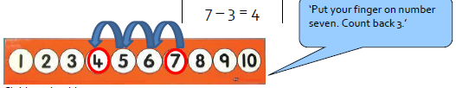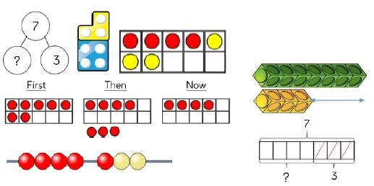
Children should:
- model subtraction practically and using number tracks, tens frames, number lines, 100 squares, part-part wholes and bar models in a practical way.
- Find the difference between - this is to be done practically using the language ‘find the difference between’ and ‘how many more than?’
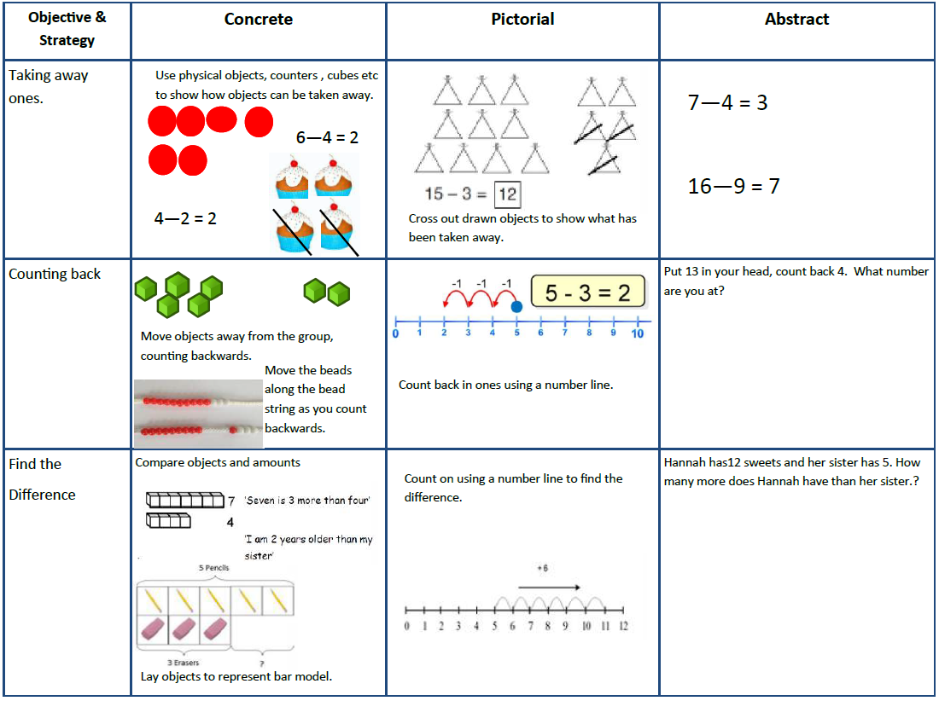
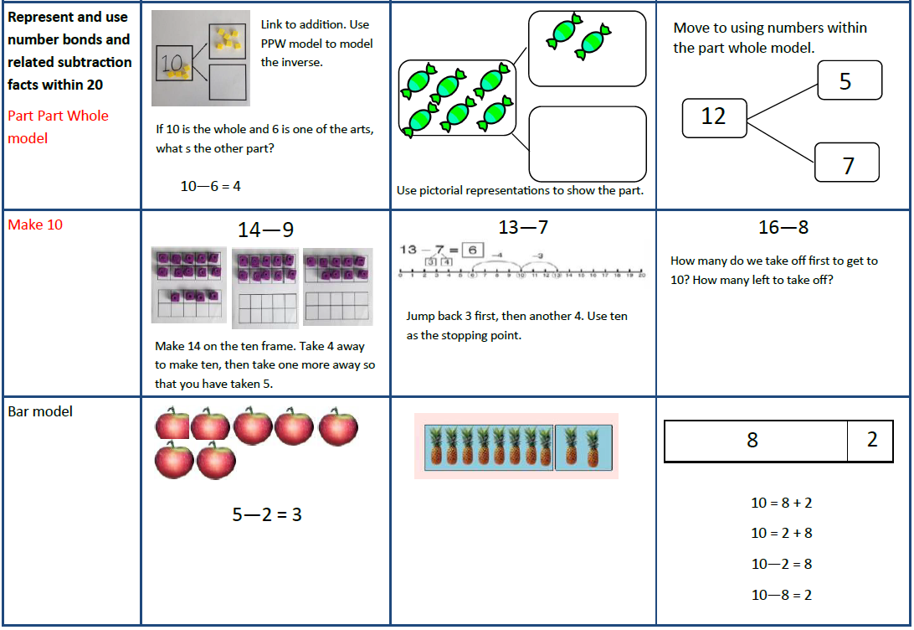
Key Vocabulary
Equal to, take, take-away, less, minus, subtract, leaves, difference between, how many more, how many fewer/ less than, most, least, count back, how many left, how much less is…, difference

National Curriculum requirements
- Read, write and interpret mathematical statements involving subtraction (-) and equals (=) signs represent and use number bonds and related subtraction facts within 20
- Subtract one-digit and related subtraction facts within 20
- Solve one-step problems that involve subtraction, using concrete objects, pictorial representations, and missing number problems such as 7= ___ - 9

Year 2
NB Ensure that children are confident with the methods outlined in the previous stage’s guidance before moving on.
When children are confident, they move on to two digit numbers.
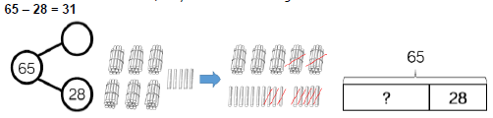
Children will use an empty number line in conjunction with a 100 square to show jumps of tens.
Subtraction, using partitioning, on an empty number line:
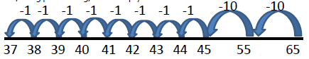
Children move to more formal recording using partitioning method, setting out as follows:
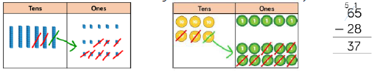
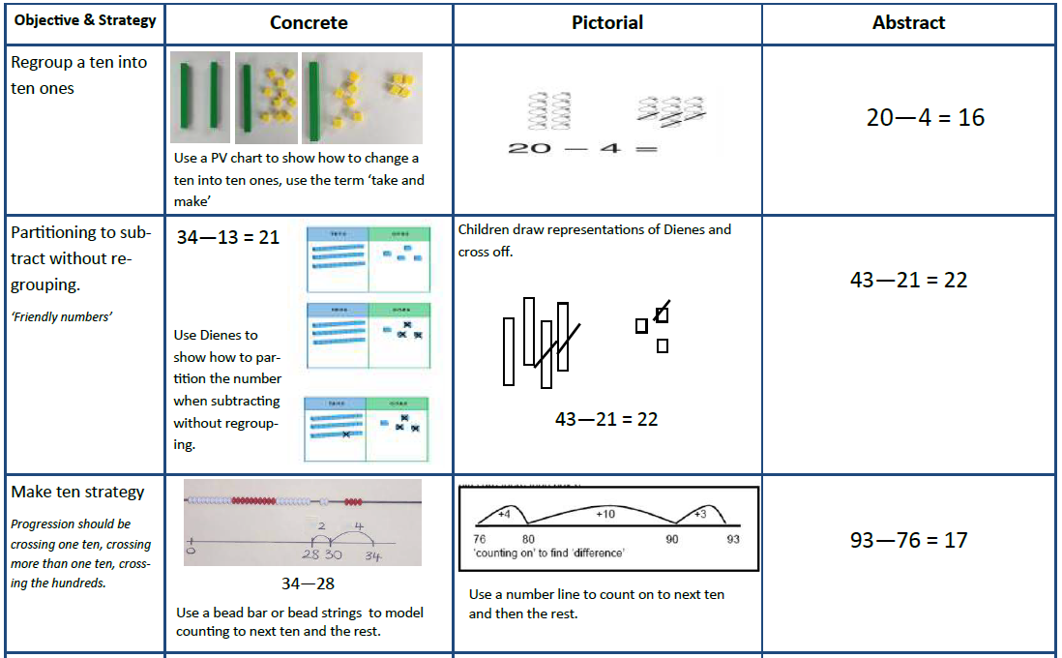
Key Vocabulary
Equal to, take, take-away, less, minus, subtract, leaves, difference between, how many more, how many fewer/less than, most, least, count back, how many left, how much less is…, difference, count on, strategy, partition tens (T), ones (O)

National curriculum requirements
- Solve problems with addition and subtraction:
    - Using concrete objects and pictorial representations, including those involving numbers, quantities and measures
    - Applying their increasing knowledge of mental and written methods
- Recall and use subtraction facts to 20 fluently, and derive and use related facts up to 100
- Subtract numbers using concrete objects, pictorial representations, and mentally, including:
    - a two-digit number and ones
    - a two-digit number and tens
    - adding three one-digit numbers
- show that subtraction of one number from another cannot be done in any order
- recognise and use the inverse relationship between addition and subtraction and use this to check calculations and solve missing number problems

Year 3
Subtract on an empty number line (ENL) by counting on. Children should understand when to count back where appropriate, using place value or number facts. This skill should be reinforced through mental work.
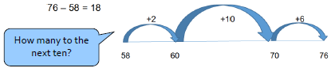
Children continue to use part-part whole models and bar models to represent their subtractions.
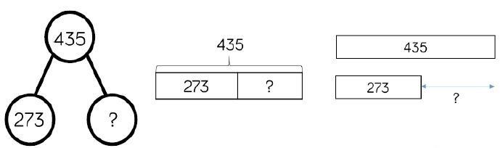
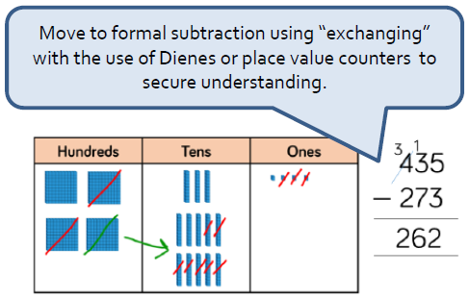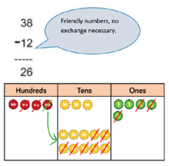
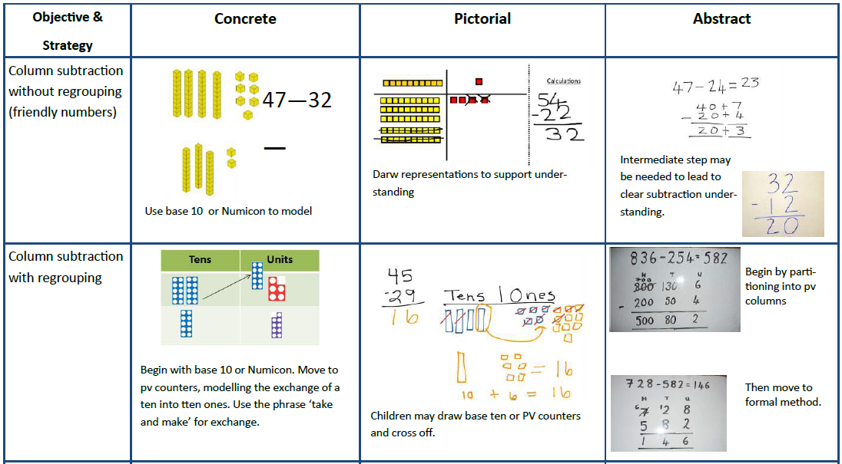
Key Vocabulary
Equal to, take, take-away, less, minus, subtract, leaves, difference between, how many more, how many fewer/ less than, most, least, count back, how many left, how much less is….., difference, count on, strategy, partition, tens (T) ones (O) take and make, exchange, digit, value, hundreds (H)

National Curriculum requirements
- subtract numbers mentally, including:
    - a three-digit number and ones
    - a three-digit number and tens
    - a three-digit and hundreds
- subtract numbers with up to three digits, using formal written methods of column subtraction
- estimate the answer to a calculation and use inverse operations to check answers
- solve problems, including missing number problems, using number-facts, place value, and more complex subtraction

Year 4
Subtract using formal column subtraction, using mathematical manipulatives to build strong conceptual and fluent knowledge:
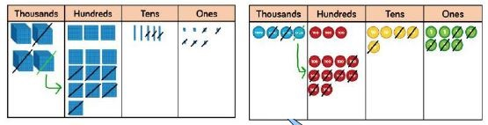
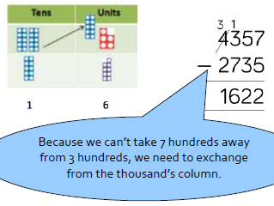
Use complementary addition to subtract amounts of money, and for subtractions where the larger number is a near multiple of 1000 or 100.
£20 - £6.37 = £13.63
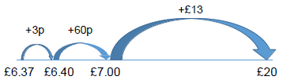
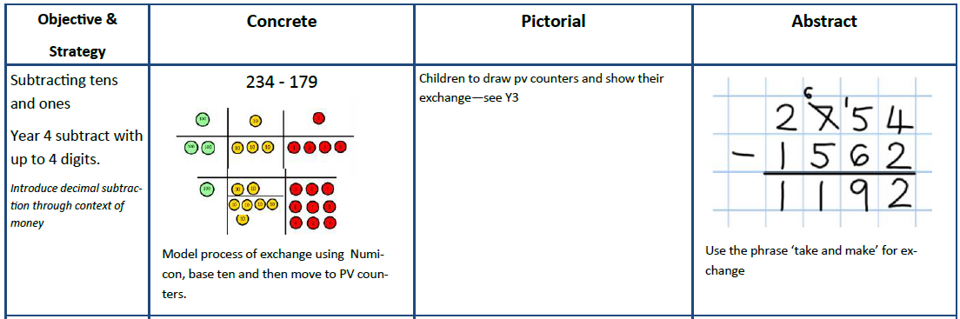
Key Vocabulary
Equal to, take, take-away, less, minus, subtract, leaves, difference between, how many more, how many fewer/less than, most, least, count back, how many left, how much less is ……, difference count on, strategy, partition, tens (T), ones (O) take and make, exchange, digit, value, hundreds (H) inverse
National Curriculum requirements
- subtract numbers with up to 4 digits using the formal written methods of column subtraction
- where appropriate estimate and use inverse operations to check answers to a calculation
- solve subtraction two-step problems in contexts, deciding which operations and methods to use and why
Year 5
At this stage, children subtract numbers with more than 4 digits including money, measures and decimals with different numbers of decimal places.
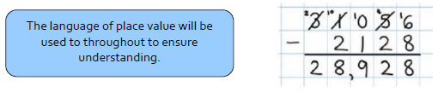
As for previous stage, counting up with an empty number line will be encouraged when the larger number is a multiple of 100, 1000 etc.
Subtract with decimal values, including mixtures of integers and decimals and aligning the decimal point. Children will continue to use mathematical manipulatives alongside other representations such as part-part whole and bar models.
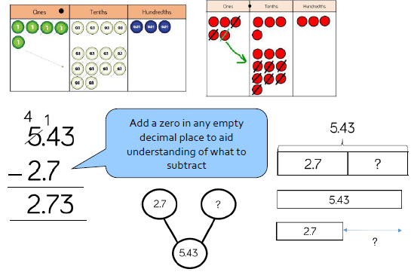
Year 5- Subtract  with at least 4 digits,  including money  and measures.  Subtract with decimal  values, including mixtures  of integers and decimals  and aligning the decimal | As Year 4  Model process of exchange using Numicon,  base ten and then move to PV counters  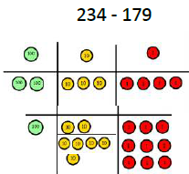 | Children to draw pv counters and show their exchange—see Y3 | Use zeros for placeholders

Key Vocabulary
Equal to, take, take-away, less, minus, subtract, leaves, difference between, how many more, how many fewer/less than, most, least, count back, how many left, how much less is….., difference, count on, strategy, partition, tens (T), ones (O) take and make, exchange, digit, value, hundreds (H) inverse, tenths (t) hundredths (h) decimal point, decimal
National Curriculum requirements
- subtract whole numbers with more than 4 digits, including formal written methods (column addition and subtraction
- subtract numbers mentally with increasingly large numbers
- use round to check answers to calculations and determine, in the context of a problem, levels of accuracy
- solve subtraction multi-step problems in contexts, deciding which operations and methods to use and why

Year 6
Year 6 continue to develop the formal written method for subtraction with both larger integers and decimals in an abstract formal method approach. Some children may still need to use concrete and pictorial representations using base 10, place value counters and bar models. They apply this method when working in contexts such as money and measures.
Pupils should apply their knowledge of a range of mental strategies, mental recall skills, informal and formal written methods when selecting the appropriate method to work out subtraction problems. Opportunities to discuss the appropriateness of methods need to be planned for.
Year 6—Subtract  with increasingly  large and more  complex numbers  and decimal values. | As Year 4  Model process of exchange using Numicon,  base ten and then move to PV counters | Children to draw pv counters and show their exchange—see Y3 | Use zeros for placeholders  subtract in context of money, measures, including decimals with different numbers  of decimal places.

Key Vocabulary
Minuend, subtrahend, equal to, take, take-away, less, minus, subtract, leaves, difference between, how many more, how many fewer/less than, most, least, count back, how many left, how much less is…., difference, count on, strategy, partition, tens (T) ones (O), take and make, exchange, digit, value, hundreds (H), inverse, tenths (t) hundredths (h) thousandths (th) decimal point, decimal

National Curriculum Requirements
- use their knowledge of the order of operations to carry out calculations involving the four operations BODMAS
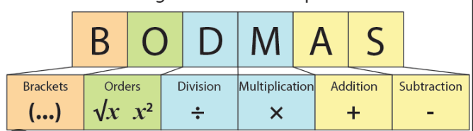
- solve subtraction multi-step problems in contexts, deciding which operations and methods to use and why
- use estimation to check answers to calculations and determine, in the context of a problem, an appropriate degree of accuracy.

Multiplication

EYFS
Children will engage in a wide variety of songs, rhymes, games and activities.
In practical activities and through discussion they will begin to solve problems involving doubling.

Count repeated groups of the same size.
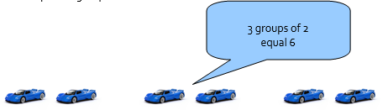
Counting in 2s, 5s and 10s.
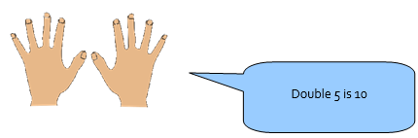
Key Vocabulary
Lots of, groups of.

Key skills for multiplication at EYFS
• Solve problems, including doubling

Year 1
Children will count repeated groups of the same size in practical contexts. They will use the vocabulary associated with multiplication in practical contexts.
They will solve practical problems that involve combining groups of 2, 5 or 10. E.g. socks, fingers and cubes. Children will be exposed to multiple representations to build the concept of multiple groups of.
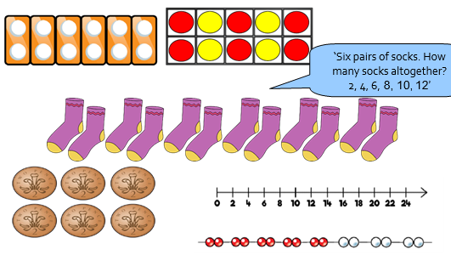
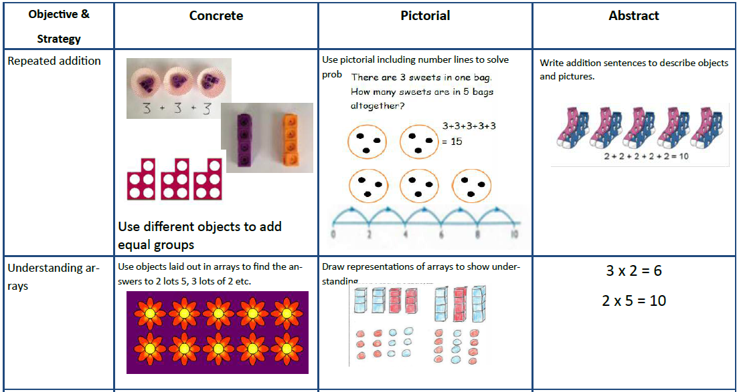
Key Vocabulary
Multiply, times, lots of, groups of

National Curriculum requirements
• Count in multiples of 2, 5 and 10
• Recognise doubles to double 6
• Solve simple one-step problems involving multiplication and division, calculating the answer using concrete objects, pictorial representations and arrays with the support of the teacher.

Year 2
Starting from zero, make equal jumps on a number line to work out multiplication facts and write multiplication sentences. Children can skip count with the 2,3, 5 and 10s.
Use arrays, Numicon and visual representations to help with calculations and to teach children to understand the commutative law of multiplication.
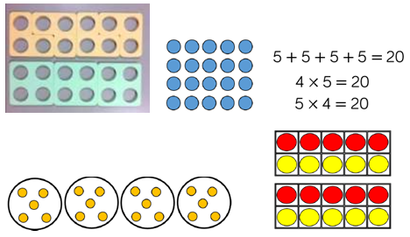
Use repeated addition on an empty number line: 6 x 5 = 30

Learn doubles to double 20
Begin to double multiples of 5 to 100
Begin to double two-digit numbers less than
50 with 1s digits of 1, 2, 3 4 or 5
22 x 2 =
Doubling | Model doubling using dienes and PV counters.  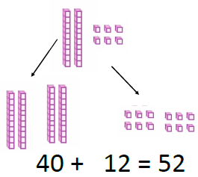 | Draw pictures and representations to  show how to double numbers | Partition a number and then double each part before recombining it back together.  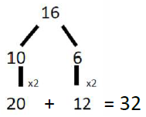
Counting in multiples  of 2, 3, 4, 5, 10  from 0  (repeated addition) | Count the groups as children are skip  counting, children may use their fingers as they are skip counting. Use bar models.  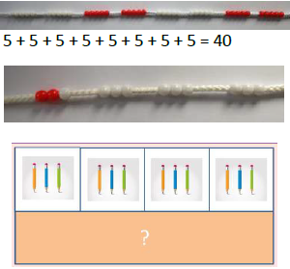 | Number lines, counting sticks and bar models should be used to show representation of counting in multiples.  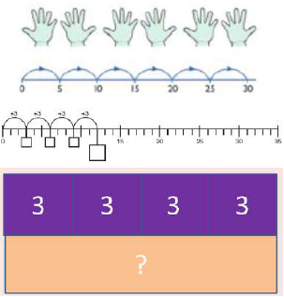 | Count in multiples of a number aloud.  Write sequences with multiples of  numbers.  0, 2, 4, 6, 8, 10  0, 3, 6, 9, 12, 15  0, 5, 10, 15, 20, 25 , 30
Multiplication is  commutative | Create arrays using counters and cubes and  Numicon.  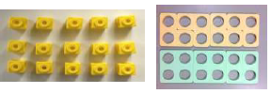  Pupils should understand that an array can represent different equations and that, as multiplication is commutative, the order of  the multiplication does not affect the answer.  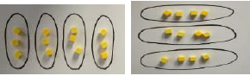 | Use representations of arrays to show different  calculations and explore commutativity. | 12 = 3 × 4  12 = 4 × 3
Using the inverse  This should be  taught alongside  division, so pupils learn how they work alongside each other. |  |  | 2 x 4 = 8  4 x 2 = 8  8 ÷ 2 = 4  8 ÷ 4 = 2  8 = 2 x 4  8 = 4 x 2  2 = 8 ÷ 4  4 = 8÷ 2  Show all 8 related fact family sentences.

Key Vocabulary
groups of, lots of, times, array, altogether, multiply, count, multiplied by, repeated addition, column, row, sets of, equal groups, times as big as, once, twice, three times...

National Curriculum requirements
• Count in steps of 2, 3 and 5 from zero and in 10s from any number
• Know the 2X, 5X and 10X tables and begin to say how many 10s are in 40 or how many 5s are in 30; recognise odd and even answers
• Write and calculate number statements using x and = signs
• Show that multiplication can be done in any order
• Solve a range of problems involving multiplication, using concrete objects, arrays, repeated addition, Numicon, mental methods and multiplication facts.

Year 3
Children continue to use practical manipulatives to show multiplication as groups of using Dienes, Numicon and place value counters. Partitioning method is used for multiplication of a teen number by a one-digit number:
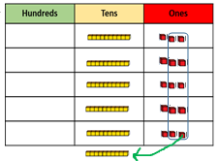
13 x 5 = 65 (Partition 13 into 10 + 3)
10 x 5 = 50
3 x 5 = 15
50 + 15 = 65
This can also be complete on an empty numberline:
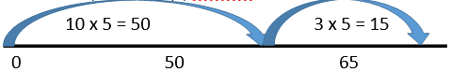
This will lead into expanded short multiplication:

14 x 8 = 112 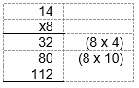
Children continue to use arrays where appropriate
Grid method | Show the links with arrays to first introduce the grid method.  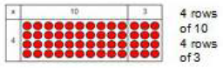  Move onto base ten to move towards a  more compact method.  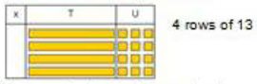  Move on to place value counters to show  how we are finding groups of a number. We are multiplying by 4 so we need 4 rows  Fill each row with 126  Add up each column, starting with the ones  making any exchanges needed  Then you have your answer. | Children can represent their work with place  value counters in a way that they understand.  They can draw the counters using colours to show different amounts or just use the circles in the different columns to show their thinking as shown below.  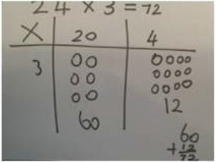  Bar model are used to explore missing numbers | Start with multiplying by one digit numbers  and showing the clear addition  alongside the grid.  Moving forward, multiply by a 2 digit number  showing the different rows within the grid  method.

Key Vocabulary
groups of, lots of, times, array, altogether, multiply, count, multiplied by, repeated addition, column, row, sets of, equal groups, times as big as, once, twice, three times…, partition, multiple, product, tens, units, value

National Curriculum requirements
• Understand that multiplication is commutative, e.g. 4 x 8 is the same as 8 x 4.
• Know the 2x, 3x, 4x, 5x, 8x, 10x. All tables need to be learned to 12th multiple.
• Multiply any 2-digit number by 10 or a single-digit number by 100;
• Understand the effect of multiplying whole numbers by 10 and 100.
• Multiply a 1 digit number by a 2 digit number starting to use the expanded written method.
• Solve multiplication problems involving missing numbers

Year 4
Children continue to explore and refine the method of expanded short multiplication, moving into short multiplication methods. Children will continue to use mathematical manipulatives to further strengthen conceptual understanding.
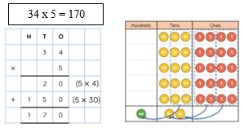
Children will refine the recording of the expanded short multiplication where appropriate and lead on to short multiplication (formal method) of a three–digit number multiplied by a one- digit number when they are ready:
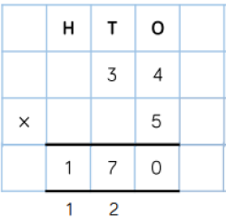
Use the language of place value to develop understanding. Ensure that the digit ‘carried over’ is written under the line in the correct column.

Grid method recap from year 3 for 2 digits x 1 digit  Move to multiplying 3 digit numbers by 1 digit. (year 4 expectation) | Use place value counters to show how we are finding groups of a number. We are multiplying by 4 so we need 4 rows  Fill each row with 126  Add up each column, starting with the ones  making any exchanges needed | Children can represent their work with place  value counters in a way that they understand.  They can draw the counters using colours to show different amounts or just use the circles in the different columns to show their thinking as shown below.  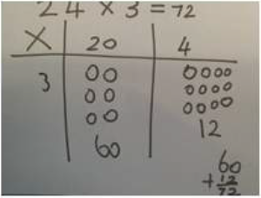 | Start with multiplying by one digit numbers  and showing the clear addition  alongside the grid.
Column multiplication | Children can continue to be supported by  place value counters at the stage of multiplication.  This initially done where there is no  regrouping. 321 x 2 = 642  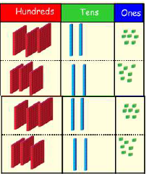  It is important at this stage that they always  Multiply the ones first. | 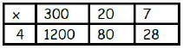  The grid method my be used to show how this  relates to a formal written method.  Bar modelling and number lines can support  learners when solving problems with multiplication alongside the formal written methods. | 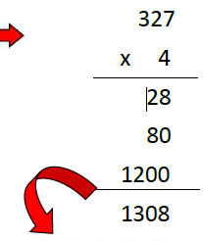  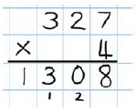

Key Vocabulary
groups of, lots of, times, array, altogether, multiply, count, multiplied by, repeated addition, column, row, sets of, equal groups, times as big as, once, twice, three times…, partition, multiple, product, tens, units, value, inverse
National Curriculum requirements
• Multiply 1 and 2 digit numbers by 10, 100 and 1000; to understand place value in decimal numbers with one place.
• Know and recite all the times tables up to 12th multiple; include multiplying by 0 (e.g. 5 x 0 = 0, 7 x 0 = 0) or by 1 (e.g. 5 x 1 = 5, ½ x 1 = ½).
• Multiply 1- digit numbers by 2-digit or friendly 3-digit numbers using expanded written method and begin to use the formal written method.
• Find doubles to double 100 and beyond, using partitioning
• Begin to double amounts of money
• Use doubling as strategy for multiplying by 2, 4, 8
• Count in multiples of 6, 7, 9, 25 and 1000

Year 5
In year 5, children will move towards more complex numbers. Initially, they will refine the method from year 4 by multiplying 4 digit numbers by a single digit, then move on to multiplying by 2 – digit numbers.
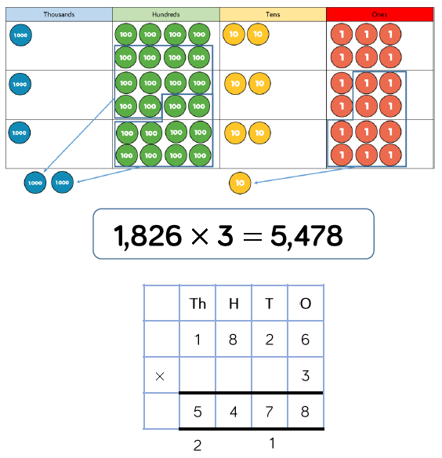
Once again, the language of place value is revised to ensure understanding. The digit that is ‘carried over’ is written under the line in the correct column.
7230 x 1 on the 1st row
7230 x 20 on the 2nd row.
Show multiplying by 10 by
putting zero in ones column first.
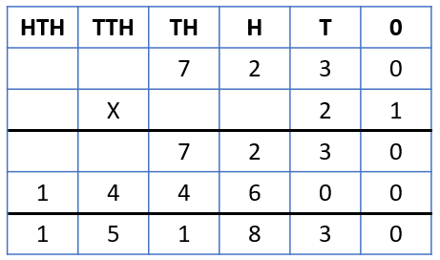
Column Multiplication for 3 and 4 digits x 1 digit. | 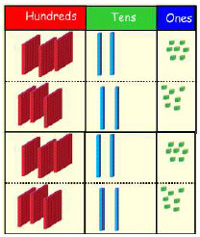  It is important at this stage that they always multiply the ones first.  Children can continue to be supported by  place value counters at the stage of multiplication.  This initially done where there is no  regrouping. 321 x 2 = 642 | 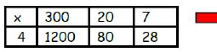 | 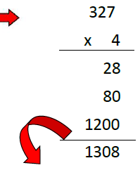  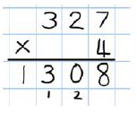
Column multiplication | Manipulatives may still be used with the corresponding long multiplication modelled  alongside. | Continue to use bar modelling to support problem solving 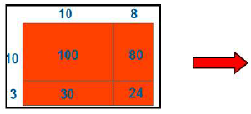 | 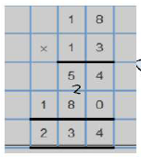  18 x 3 on the first row (8 x 3 =24, carrying the 2 for 20,  then 1 x 3)  18 x 10 on the 2nd row. Show multiplying by 10 by  Putting zero in units first

Key Vocabulary
groups of, lots of, times, array, altogether, multiply, count, multiplied by, repeated addition, column, row, sets of, equal groups, times as big as, once, twice, three times…, partition, multiple, product, tens, units, value, inverse, square, factor, integer, decimal, short/long multiplication, ‘carry’

National Curriculum requirements
• Know and recite all times tables including division facts.
• Multiply 2- and 3-digit numbers by numbers ≤12 ;
• multiply 2-digit by 2-digit numbers.
• Identify multiples and factors, using knowledge of multiplication tables up to 12 x 12
• Scale up or down by a factor of 2, 5 or 10
• Multiply integers and decimals by 10, 100, 1000
• Recognise and use squared, cubes and their notations

Year 6
In year 6, children will use short and long multiplication, as in year 5, and multiply decimals with up to 2 decimal places by a single digit.
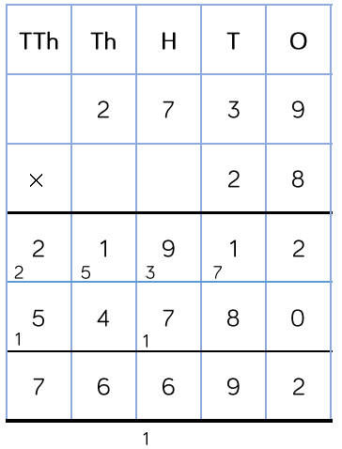
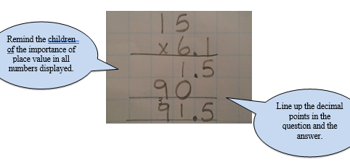
Column Multiplication for 3 and 4 digits x 1 digit.  (As in Year 5) | It is important at this stage that they always multiply the ones first.  Children can continue to be supported by  place value counters at the stage of multiplication.  This initially done where there is no  regrouping. 321 x 2 = 642
Column multiplication  (As in Year 5) | Manipulatives may still be used with the corresponding long multiplication modelled  alongside. | Continue to use bar modelling to support problem solving | 18 x 3 on the first row (8 x 3 =24, carrying the 2 for 20,  then 1 x 3)  18 x 10 on the 2nd row. Show multiplying by 10 by  Putting zero in units first

Key Vocabulary
groups of, lots of, times, array, altogether, multiply, count, multiplied by, repeated addition, column, row, sets of, equal groups, times as big as, once, twice, three times…, partition, multiple, product, tens, units, value, inverse, square, factor, integer, decimal, short/long multiplication, ‘carry’, tenths, hundredths, decimal
National Curriculum requirements
• Recall multiplication facts up to 12 x 12
• Use short multiplication to multiply a 1-digit number by a number with up to 4 digits
• Use long multiplication to multiply a 2-digit by a number with up to 4 digits
• Use short multiplication to multiply a 1-digit number by a number with one or two decimal places, including amounts of money.
• Multiply fractions and mixed numbers by whole numbers.
• Multiply fractions by proper fractions.
• Use percentages for comparison and calculate simple percentages.
• Estimate answers using rounding and approximation

Division

EYFS
Children will engage in a wide variety of songs, rhymes, games and activities.
In practical activities and through discussion, they will begin to solve problems involving sharing into equal groups and halving.
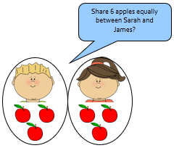
Key Vocabulary
Share, sharing, equal, equally, how many, etc.

Key skills for division at EYFS
•Solve problems, including halving.

Year 1
Children will start with practical sharing using a variety of resources. They will share objects into equal groups in a variety of situations.
They will begin to use the vocabulary associated with division in practical contexts.
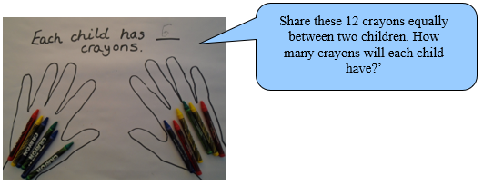
Children will move from sharing to grouping in a practical way.
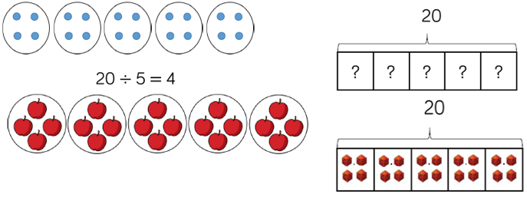
Division as sharing | 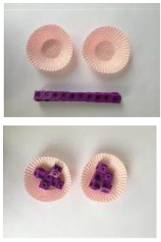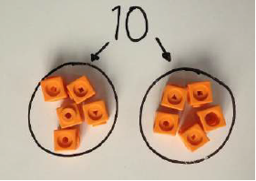  I have 10 cubes, can you share them equally in 2 groups? | Children use pictures or shapes to share quantities.  8 shared between 2 is 4 | 12 shared between 3 is 4

Key Vocabulary
share, share equally, one each, two each..., group, groups of, lots of, array

National Curriculum requirements
•Solve one-step problems involving multiplication and division, by calculating the answer using concrete objects, pictorial representations arrays with the support of the teacher
•Through grouping and sharing small quantities, pupils begin to understand, division, and finding simple fractions of objects, numbers and quantities.

Year 2
Using objects, Numicon, arrays, pictorial representations and grouping on a number line, children will develop their understanding of division further.
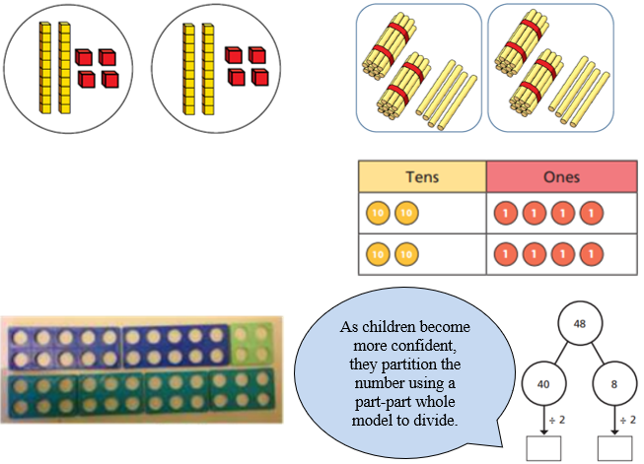
When children are ready, use an empty number line to count forwards:
18 ÷ 3 = 6
In this method, children group from zero in equal jumps to find out, ‘how many groups of _ make _.’
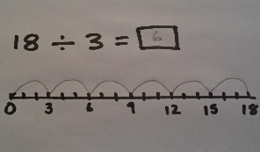
Division as sharing | I have 10 cubes, can you share them equally in 2 groups? | Children use pictures or shapes to share quantities.  8 shared between 2 is 4  Children use bar modelling to show and support understanding.  12 ÷ 4 = 3 | 12 ÷ 3 = 4
Division as grouping | Divide quantities into equal groups.  Use cubes, counters, objects or place value counters to aid understanding. | Use number lines for grouping  Think of the bar as a whole. Split it into the number of groups you are dividing by and work out how many would be within each group. | 28 ÷ 7 = 4  Divide 28 into 7 groups.  How many are in each group?

Key Vocabulary
share, share equally, one each, two each..., group, equal groups of, lots of, array, divide, divided by, divided into, division, grouping, number line, left, left over

National Curriculum requirements
•Count in steps of 2, 3, and 5 from 0
•Recall and use multiplication and division facts for the 2, 5 and 10 multiplication tables, including recognising odd and even numbers.
•Calculate mathematical statements for multiplication and division within the multiplication tables and write them using the x, ÷ and = signs.
•Show that multiplication of two numbers can be done in any order (commutative) and division of one number by another cannot.
•Solve problems involving multiplication and division, using materials, arrays, repeated addition, mental methods, and multiplication and division facts, including problems in contexts.

Year 3
In year 3 children will continue to use practical resources, pictures, diagrams, number lines, arrays and the ÷ sign to record division calculations.
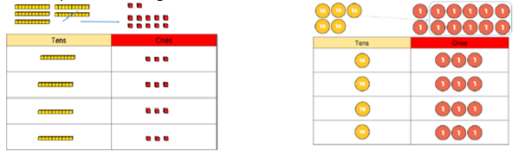
Children will use the formal layout using multiplication/division facts that they know through the learning of their tables:
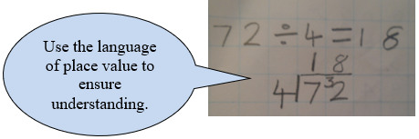
They will continue to use the formal written layout (above) then progress on to the formal written method of short division.
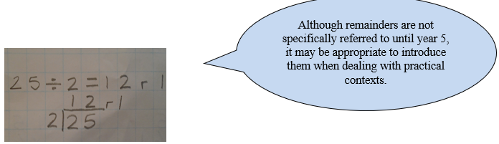
Division as grouping | Use cubes, counters, objects or place value counters to aid understanding.  24 divided into groups of 6 = 4 | Continue to use bar modelling to aid solving  division problems. | How many groups of 6 in  24?  24 ÷ 6 = 4
Division with arrays | Link division to multiplication by creating an array and thinking about the number sentences that can be created.  Eg 15 ÷ 3 = 5  5 x 3 = 15  15 ÷ 5 = 3  3 x 5 = 15 | Draw an array and use lines to split the array  into groups to make multiplication and division sentences | Find the inverse of multiplication and division  sentences by creating eight linking number  sentences.  7 x 4 = 28  4 x 7 = 28  28 ÷ 7 = 4  28 ÷ 4 = 7  28 = 7 x 4  28 = 4 x 7  4 = 28 ÷ 7  7 = 28 ÷ 4
Division with remainders. | 14 ÷ 3 =  Divide objects between groups and see how much is left over  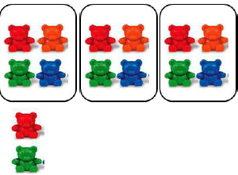 | Jump forward in equal jumps on a number line  then see how many more you need to jump to  find a remainder.  Draw dots and group them to divide an amount  and clearly show a remainder.  Use bar models to show division with remainders. | Complete written divisions and show the remainder  using r.  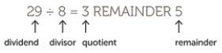

Key Vocabulary
share, share equally, one each, two each..., group, equal groups of, lots of, array, divide, divided by, divided into, division, grouping, number line, left, left over, inverse, short division, ‘carry‘, remainder, multiple

National Curriculum requirements
•Recall and use division facts for the 2, 3, 4, 5, 8 and 10 multiplication tables
•Write and calculate mathematical statements for division using the multiplication tables that they know, including for two-digit numbers divided by one digit
•Solve problems, in contexts, and including missing number problems, involving division.
•Pupils develop efficient mental methods, for example, using division facts (e.g. using 3 × 2 = 6, 6 ÷ 3 = 2 and 2 = 6 ÷ 3) to derive related facts (30 × 2 = 60, so 60 ÷ 3 = 20 and 20 = 60 ÷ 3).
•Pupils develop reliable written methods for division, starting with calculations of 2-digit numbers by 1-digit numbers using an ENL.
•Halve even numbers up to 50 and multiples of ten to 100
•Perform divisions within the tables including those with remainders, e.g. 38 ÷ 5.

Year 4
Children will practise and refine the formal method for short division where appropriate and lead on to more complex examples involving three digit numbers and remainders. Children will still need to use physical manipulatives to understand the concept of exchange.
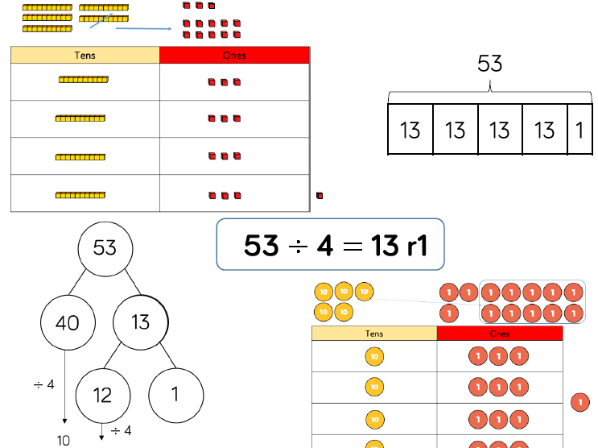or
NB: Children will be reminded of the importance of accurate place value and keeping digits in the correct squares.
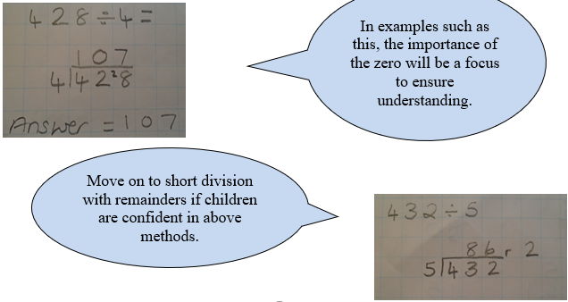

Divide at least 3 digit  numbers by 1 digit.  Short Division | 96 ÷ 3  Use place value counters to divide using the bus stop method alongside  42 ÷ 3=  Start with the biggest place value, we are sharing 40 into three groups. We can put 1 ten in each group and we have 1 ten left over.  We exchange this ten for ten ones and then share the ones equally among the groups.  We look how much in 1 group so the answer is 14. | Students can continue to use drawn diagrams  with dots or circles to help them divide numbers into equal groups.  Encourage them to move towards counting in  multiples to divide more efficiently. | Begin with divisions that divide equally with no remainder.  Move onto divisions with a remainder.  Finally move into decimal places to divide the total accurately.

Key Vocabulary
share, share equally, one each, two each..., group, equal groups of, lots of, array, divide, divided by, divided into, division, grouping, number line, left, left over, inverse, short division, ‘carry‘, remainder, multiple, divisible by, factor

National Curriculum requirements
•Use a written method to divide a 2-digit or a 3-digit number by a single-digit number.
•Give remainders as whole numbers.
•Recall multiplication and division facts for all numbers up to 12 x 12.
•Use place value, known and derived facts to multiply and divide mentally, including: multiplying and dividing by 10 and 100 and 1.
•Pupils practise to become fluent in the formal written method of short division with exact answers when dividing by a one-digit number
•Pupils practise mental methods and extend this to three-digit numbers to derive facts, for example 200 × 3 = 600 so 600 ÷ 3 = 200
•Pupils solve two-step problems in contexts, choosing the appropriate operation, working with increasingly harder numbers. This should include correspondence questions such as three cakes shared equally between 10 children.

Year 5
In year 5, children will be able to use the short division method to divide numbers up to 4 digits by a one-digit number. For those who are more confident, they could progress to dividing by two-digit numbers.
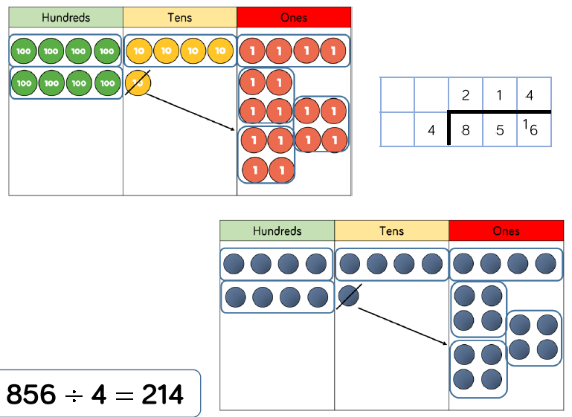
Children are taught how to express their answers as remainders, decimals or fractions.
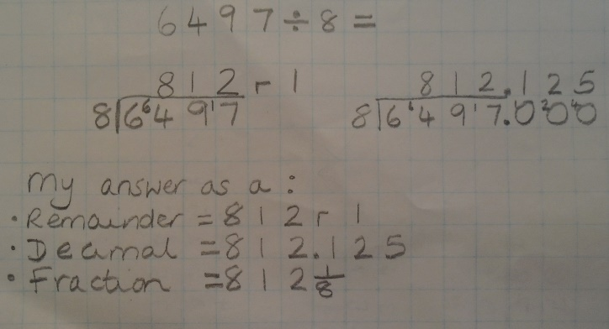
In addition, children should be able to interpret remainders appropriately for real life contexts, including using money and measures.
Rounding up or down?
Each CD rack holds 12 CDs. If Jenny has 134 CDs, how many racks will she need to hold all her CDs?
Divide at least 3 digit  numbers by 1 digit.  Short Division  (As in Year 4) | 96 ÷ 3  Use place value counters to divide using the bus stop method alongside  42 ÷ 3=  Start with the biggest place value, we are sharing 40 into three groups. We can put 1 ten in each group and we have 1 ten left over.  We exchange this ten for ten ones and then share the ones equally among the groups.  We look how much in 1 group so the answer is 14. | Students can continue to use drawn diagrams  with dots or circles to help them divide numbers into equal groups.  Encourage them to move towards counting in  multiples to divide more efficiently. | Begin with divisions that divide equally with no remainder.  Move onto divisions with a remainder.  Finally move into decimal places to divide the total accurately.

Key Vocabulary
share, share equally, one each, two each..., group, equal groups of, lots of, array, divide, divided by, divided into, division, grouping, number line, left, left over, inverse, short division, ‘carry‘, remainder, multiple, divisible by, factor quotient, prime number, prime factors, composite number (non-prime)

National Curriculum requirements
•Recall multiplication and division facts for all numbers up to 12 x 12 (as in Y4).
•Multiply and divide numbers mentally, drawing upon known facts.
•Identify multiples and factors, including finding all factor pairs of a number, and common factors
of two number.
•Solve problems involving multiplication and division where larger numbers are decomposed into their factors.
•Multiply and divide whole numbers and those involving decimals by 10, 100 and 1000.
•Use the vocabulary of prime numbers, prime factors and composite (non-prime) numbers.
•Work out whether a number up to 100 is prime, and recall prime numbers to 19
•Divide numbers up to 4 digits by a one-digit number using the formal written method of short division and interpret remainders appropriately for the context
•Use multiplication and division as inverses. Interpret non-integer answers to division by expressing results in different ways according to the context, including with remainders, as fractions, as decimals or by rounding (e.g. 98 ÷ 4 = 24 r 2 = 241/2 = 24.5 ≈ 25).

Year 6
Children should continue to use the short division method taught in previous years becoming more accurate and precise in their pictorial and abstract understanding and representation.
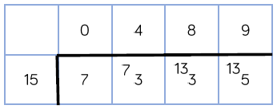
They move on to dividing by two-digit numbers using long division. As in year 5, real life contexts will be used.
Chunking method of division:
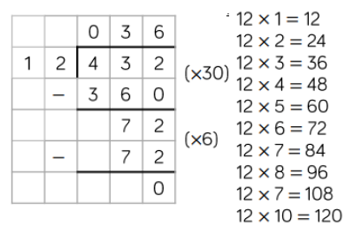
Formal long division method: 8640 ÷15 =
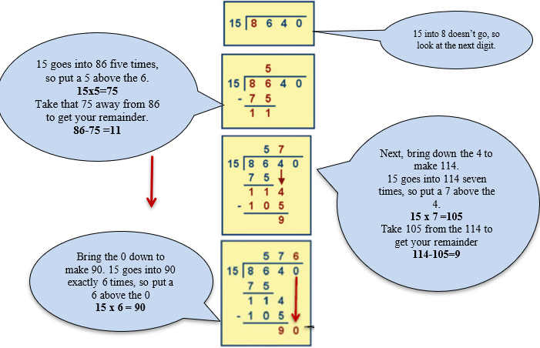
Divide at least 3 digit  numbers by 1 digit.  Short Division  (As in Year 4) | 96 ÷ 3  Use place value counters to divide using the bus stop method alongside  42 ÷ 3=  Start with the biggest place value, we are sharing 40 into three groups. We can put 1 ten in each group and we have 1 ten left over.  We exchange this ten for ten ones and then share the ones equally among the groups.  We look how much in 1 group so the answer is 14. | Students can continue to use drawn diagrams  with dots or circles to help them divide numbers into equal groups.  Encourage them to move towards counting in  multiples to divide more efficiently. | Begin with divisions that divide equally with no remainder.  Move onto divisions with a remainder.  Finally move into decimal places to divide the total accurately.

Key Vocabulary
share, share equally, one each, two each..., group, equal groups of, lots of, array, divide, divided by, divided into, division, grouping, number line, left, left over, inverse, short division, ‘carry‘, remainder, multiple, divisible by, factor quotient, prime number, prime factors, composite number (non-prime) common factor

National Curriculum requirements
•Recall and use multiplication and division facts for all numbers to 12 x 12 for more complex calculations
•Divide numbers up to 4 digits by a two-digit whole number using the formal written method of long division, and interpret remainders as whole number remainders, fractions, or by rounding, as appropriate for the context. Use short division where appropriate.
•Perform mental calculations, including with mixed operations and large numbers.
•Identify common factors, common multiples and prime numbers.
•Solve problems involving all 4 operations.
•Use estimation to check answers to calculations and determine accuracy, in the context of a problem.
•Use written division methods in cases where the answer has up to two decimal places.
•Solve problems which require answers to be rounded to specified degrees of accuracy.

