1 Page steps to success
EYFS to Year 6
Addition
EYFS  Curriculum Objective: Count on from a given number  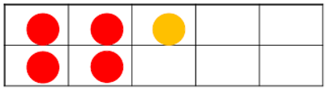 4+1=5 | Year 1  Curriculum Objective: Add one-digit numbers to 20, including zero  Step 1: Count on from a given number  4+1=5 (Recap prior knowledge from EYFS)  Progress onto using a number line    Step 2:  Using a part-part-whole model to combine groups and extending to the written calculation  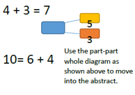
Year 2  Curriculum Objective: Add numbers using concrete objects, pictorial representations including mentally  Step 1: (recap prior knowledge from Year 1)  Using a part-part-whole model to combine groups and extending to the written calculation  Step 2:  Introduce the column method. Carry the 10 below.  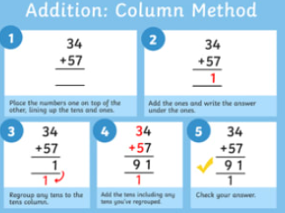 | Year 3  Curriculum Objective: add and subtract numbers with up to three digits, using formal written methods of column addition and subtraction  Step 1: build on column method by introducing the hundreds column. Carry the tens and hundreds below  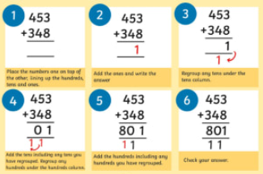
Year 4 & Year 5  Curriculum Objective: add numbers with up to 4 digits, using the formal written methods of column addition and subtraction  Year 5  add whole numbers with more than 4 digits, including using formal written methods  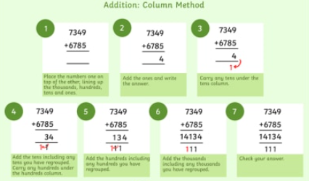 | Year 6  Curriculum Objective: Use their knowledge of the order of operations to carry out calculations involving the four operations  Solve addition and subtraction multi-step problems in contexts, deciding which operations and methods to use and why

Subtraction
EYFS  Curriculum Objective: Count back from a given number  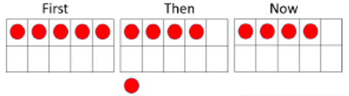  5-1=4 | Year 1  Curriculum Objective: Subtract one-digit and related subtraction facts within 20  Step 1: Count on from a given number  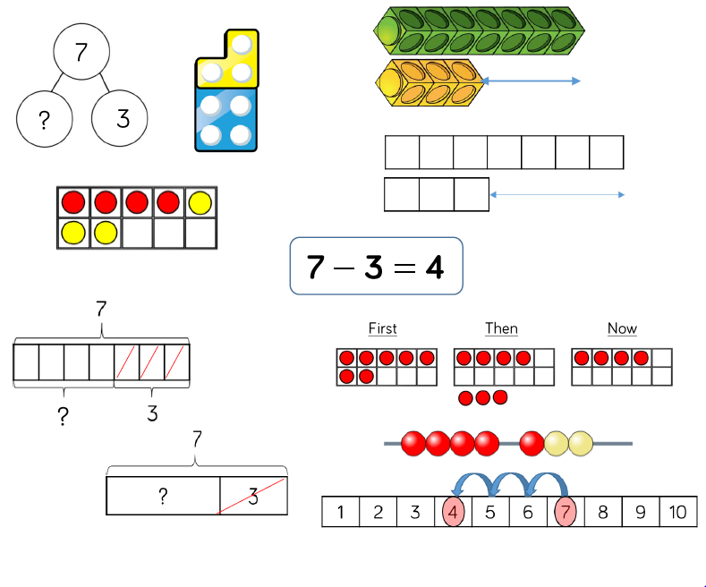 7-3=4 (Recap prior knowledge from EYFS)  Progress onto using a number line  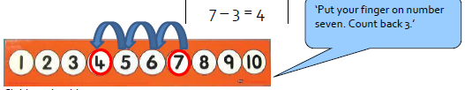  Step 2:  Using a part-part-whole model to model, moving the amounts to find what is remaining and to model the inverse and to show the missing part  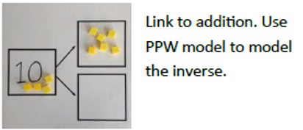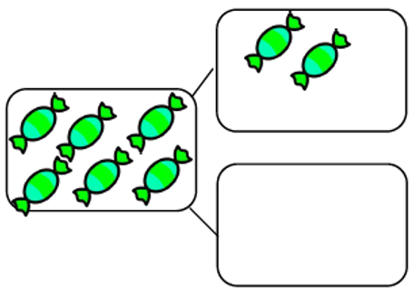
Year 2  Curriculum Objective: Subtract numbers using concrete objects, pictorial representations, and mentally  Step 1: (recap prior knowledge from Year 1)  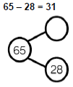  Step 2:  Introduce the column method. Exchanging the tens when needed.  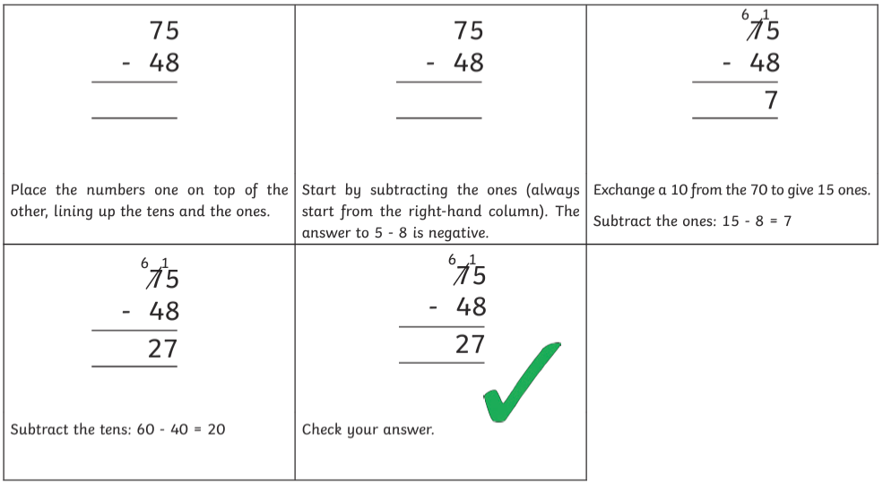 | Year 3  Curriculum Objective: subtract numbers with up to three digits, using formal written methods of column subtraction  Step 1: build on column method by introducing the hundreds column. Exchanging the hundreds and tens when needed  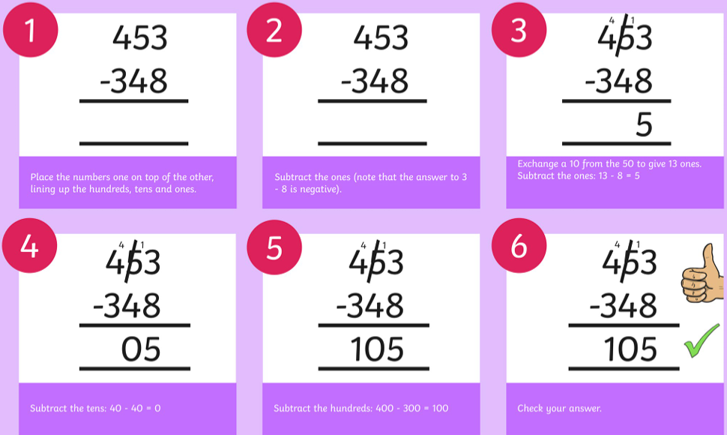
Year 4 & Year 5  Curriculum Objective: subtract numbers with up to 4 digits using the formal written methods of column subtraction  Year 5  subtract whole numbers with more than 4 digits, including formal written methods (column addition and subtraction  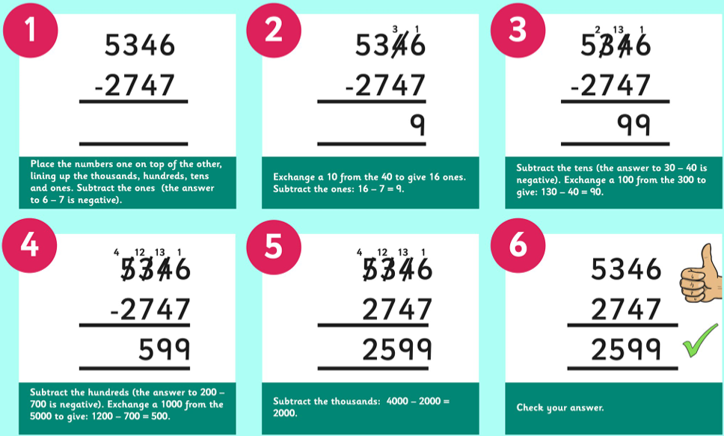 | Year 6  Curriculum Objective: Use their knowledge of the order of operations to carry out calculations involving the four operations  Solve addition and subtraction multi-step problems in contexts, deciding which operations and methods to use and why

Multiplication
EYFS  Curriculum Objective: Solve problems, including doubling  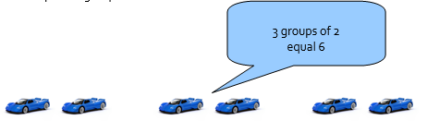  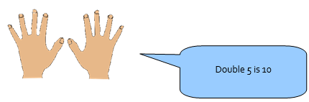 | Year 1  Curriculum Objective: Count in multiples of 2, 5 and 10  • Recognise doubles to double 6  Step 1: Recognise doubles (Recap prior knowledge from EYFS)  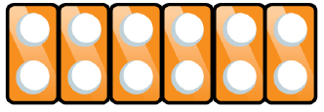  Progress onto repeated addition  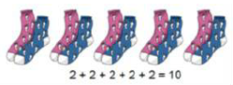  Step 2:  Using arrays to show groups of  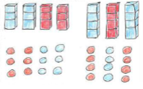
Year 2  Curriculum Objective: Know the 2X, 5X and 10X tables and begin to say how many 10s are in a given number, recognise odd and even answers  • Write and calculate number statements using x and = signs  • Show that multiplication can be done in any order  Step 1: Recap of prior Year 1 knowledge  Step 2:  Use arrays to show that multiplication can be done in any order | Year 3  Curriculum Objective: Multiply any 2-digit number by 10 or a single-digit number by 100  Multiply a 1 digit number by a 2 digit number starting to use the expanded written method  Step1: Build on Year 2 knowledge of arrays  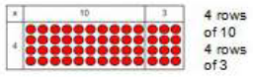  Build on column method of addition but introducing the column method to multiply  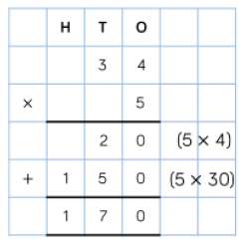
Year 4 & Year 5  Curriculum Objective: Multiply 1 and 2 digit numbers by 10, 100 and 1000; to understand place value in decimal numbers with one place.  Multiply 1- digit numbers by 2-digit or friendly 3-digit numbers using expanded written method and begin to use the formal written method.  Year 5  Curriculum Objective: Know and recite all times tables including division facts.  • Multiply 2- and 3-digit numbers  • multiply 2-digit by 2-digit numbers.  • Identify multiples and factors  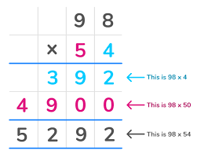 | Year 6  Curriculum Objective: Use their knowledge of the order of operations to carry out calculations involving the four operations  Solve addition and subtraction multi-step problems in contexts, deciding which operations and methods to use and why  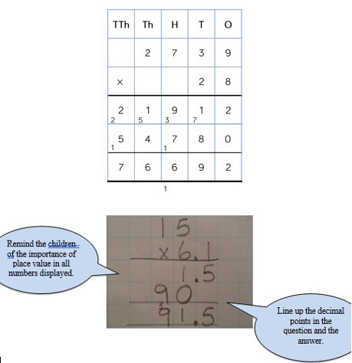
Division
EYFS  Curriculum Objective: Solve problems, including halving.  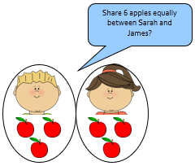 | Year 1  Curriculum Objective: Solve one-step problems involving multiplication and division  •Through grouping and sharing small quantities, pupils begin to understand, division, and finding simple fractions of objects, numbers and quantities.  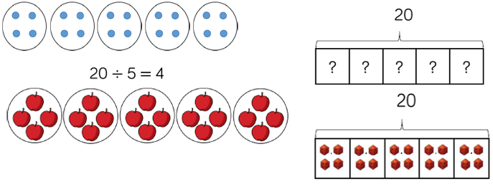
Year 2  Curriculum Objective: Recall and use division facts for the 2, 5 and 10 multiplication tables  - Show division of one number by another cannot be done in any order  - Solve problems involving multiplication and division  Step 1: Recap of prior Year 1 knowledge  Step 2: | Year 3  Curriculum Objective: Write and calculate mathematical statements for division using the multiplication tables that they know, including for two-digit numbers divided by one digit  * Perform divisions within the tables including those with remainders, e.g. 38 ÷ 5.  * Halve even numbers up to 50 and multiples of ten to 100  Begin to introduce the bus stop method
Year 4 & Year 5  Curriculum Objective: Use a written method to divide a 2-digit or a 3-digit number by a single-digit number  Recall division facts for all numbers up to 12 x 12  Use place value, known and derived facts to divide mentally. Pupils practise to become fluent in the formal written method of short division with exact answers when dividing by a one-digit number  Year 5  Divide numbers up to 4 digits by a one-digit number using the formal written method of short division and interpret remainders appropriately for the context | Year 6  Curriculum Objective: Divide numbers up to 4 digits by a two-digit whole number using the formal written method of long division, and interpret remainders as whole number remainders, fractions, or by rounding, as appropriate for the context. Use short division where appropriate.  Use written division methods in cases where the answer has up to two decimal places  