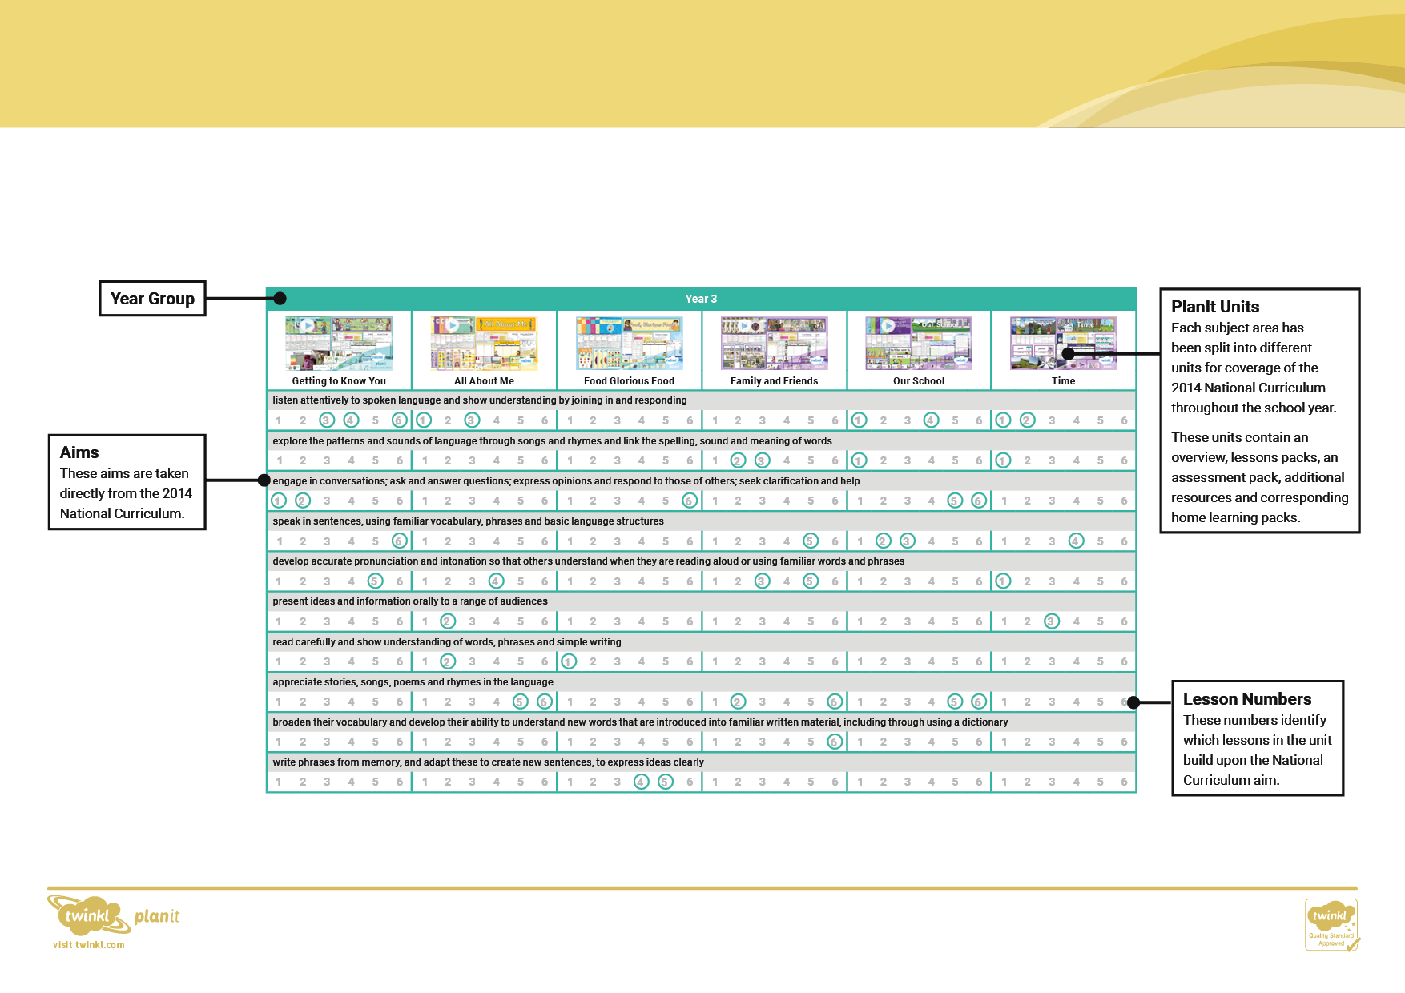

Learning another language develops children’s cultural awareness and understanding of the world around them. It extends their knowledge of how language works and helps them to develop communication skills. The twelve aims as set out in the Key Stage 2 National Curriculum for Languages are revisited throughout the four-year scheme across engaging units of work that are based on familiar themes.

**French**

Subject Overview

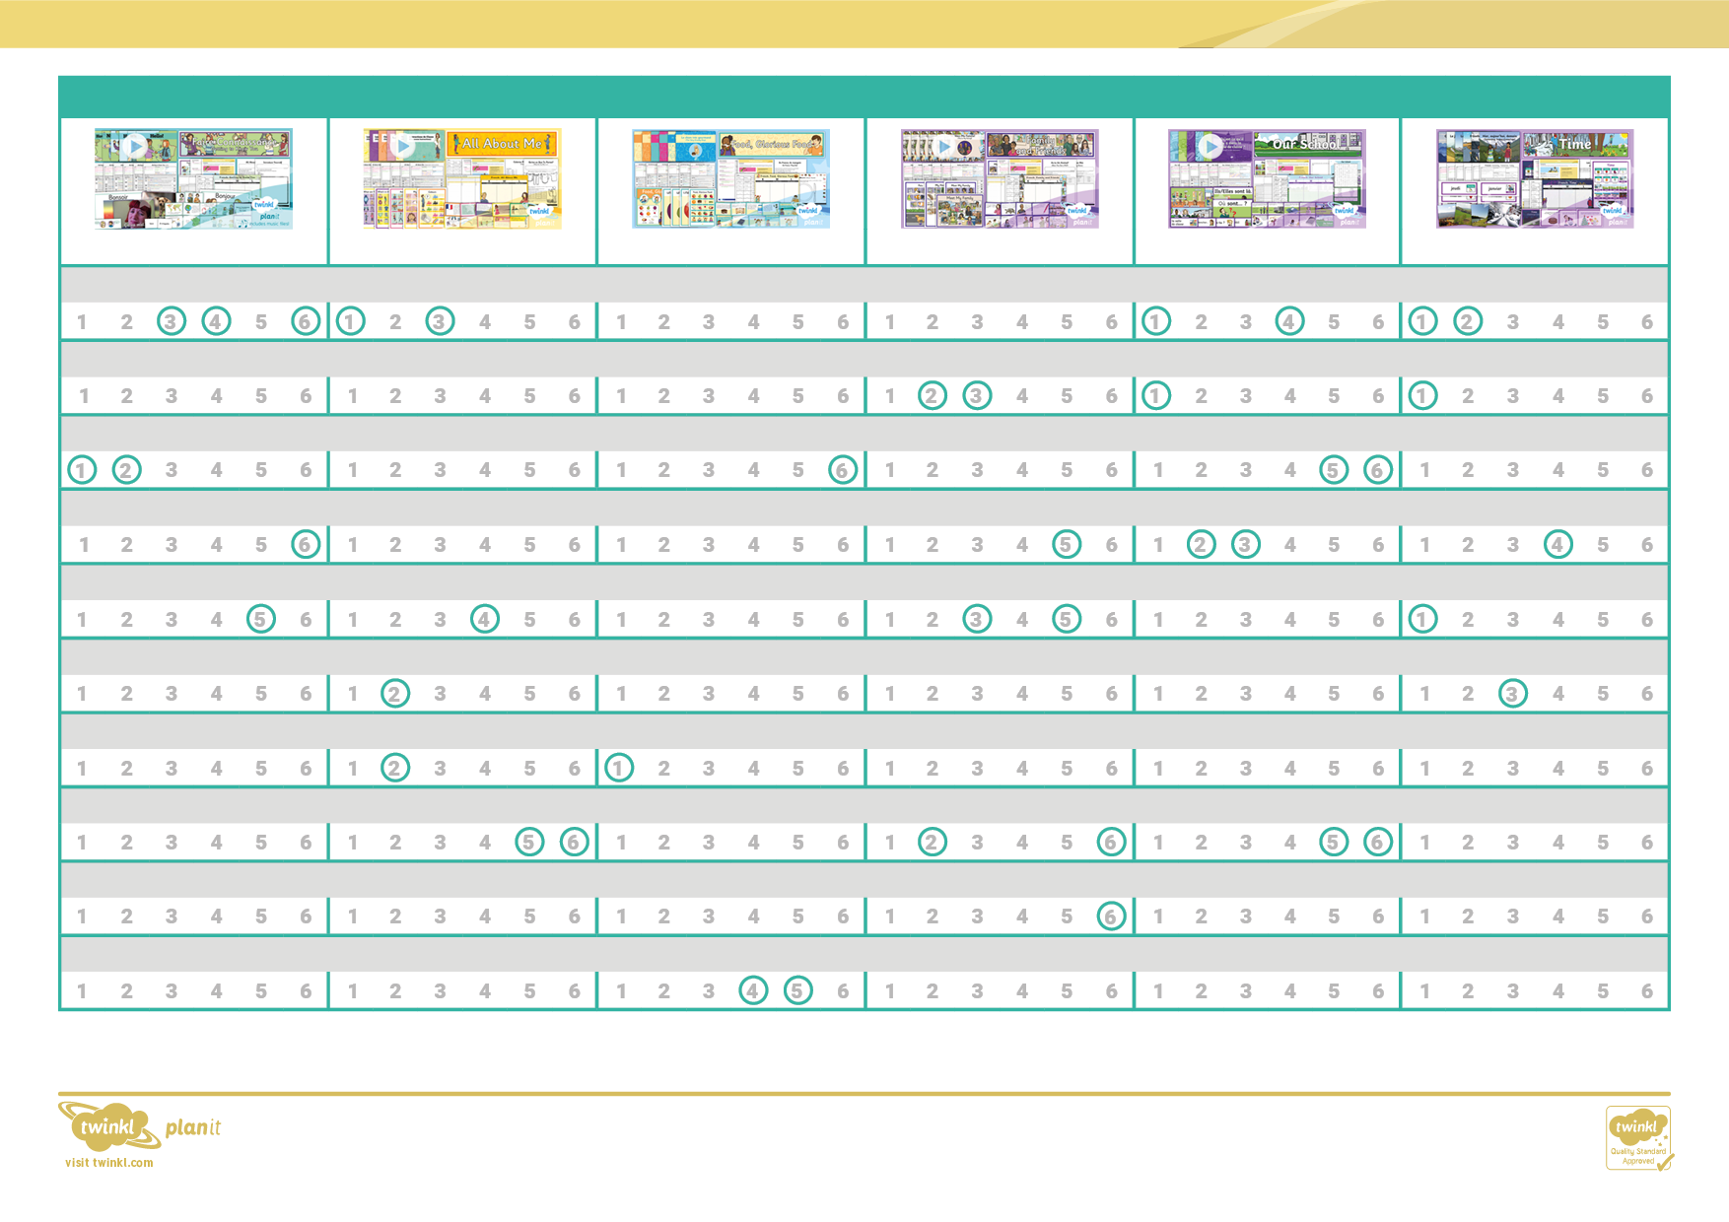

Year 3

French Subject Overview

write phrases from memory, and adapt these to create new sentences, to express ideas clearly

broaden their vocabulary and develop their ability to understand new words that are introduced into familiar written material, including through using a dictionary

appreciate stories, songs, poems and rhymes in the language

read carefully and show understanding of words, phrases and simple writing

present ideas and information orally to a range of audiences

develop accurate pronunciation and intonation so that others understand when they are reading aloud or using familiar words and phrases

speak in sentences, using familiar vocabulary, phrases and basic language structures

engage in conversations; ask and answer questions; express opinions and respond to those of others; seek clarification and help

listen attentively to spoken language and show understanding by joining in and responding

explore the patterns and sounds of language through songs and rhymes and link the spelling, sound and meaning of words

**Time**

**Our School**

**Family and Friends**

**Food Glorious Food**

**All About Me**

**Getting to Know You**

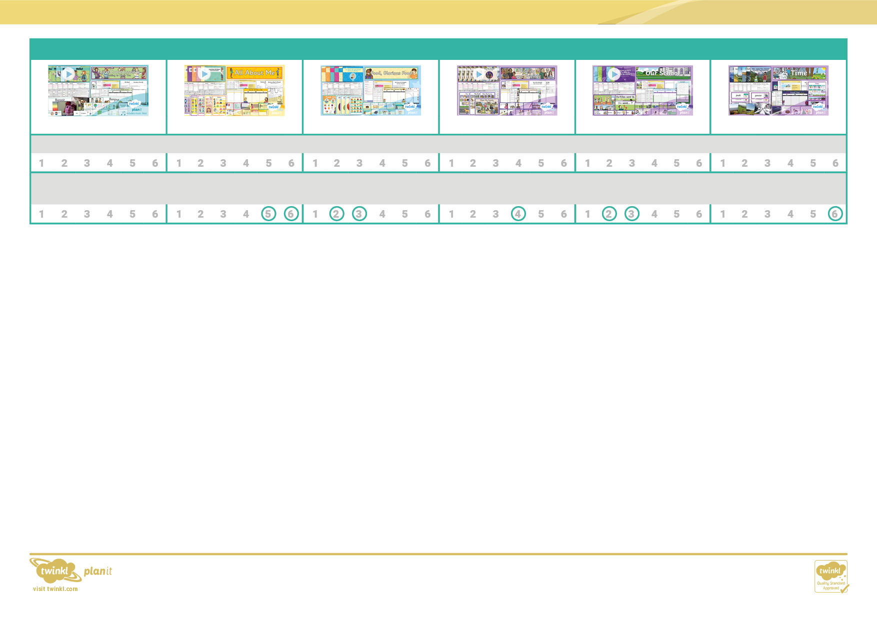

describe people, places, things and actions orally and in writing

**Time**

**Our School**

**Family and Friends**

**Food Glorious Food**

**All About Me**

**Getting to Know You**

Year 3

French Subject Overview

understand basic grammar appropriate to the language being studied, including (where relevant): feminine, masculine and neuter forms and the conjugation of high-frequency verbs; key features and patterns of the language; how to apply these, for instance, to build sentences; and how these differ from or are similar to English

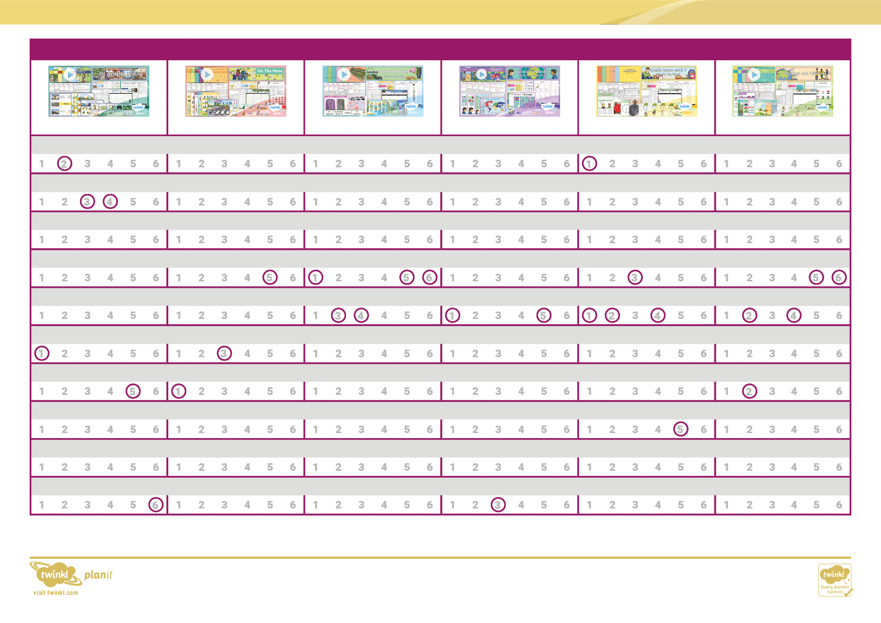

French Subject Overview

Year 4

**All Around Town**

**On the Move**

**Gone Shopping**

**Where in the World**

**What's the Time?**

**Holidays and Hobbies**

listen attentively to spoken language and show understanding by joining in and responding

explore the patterns and sounds of language through songs and rhymes and link the spelling, sound and meaning of words

engage in conversations; ask and answer questions; express opinions and respond to those of others; seek clarification and help

speak in sentences, using familiar vocabulary, phrases and basic language structures

develop accurate pronunciation and intonation so that others understand when they are reading aloud or using familiar words and phrases

present ideas and information orally to a range of audiences

read carefully and show understanding of words, phrases and simple writing

appreciate stories, songs, poems and rhymes in the language

broaden their vocabulary and develop their ability to understand new words that are introduced into familiar written material, including through using a dictionary

write phrases from memory, and adapt these to create new sentences, to express ideas clearly

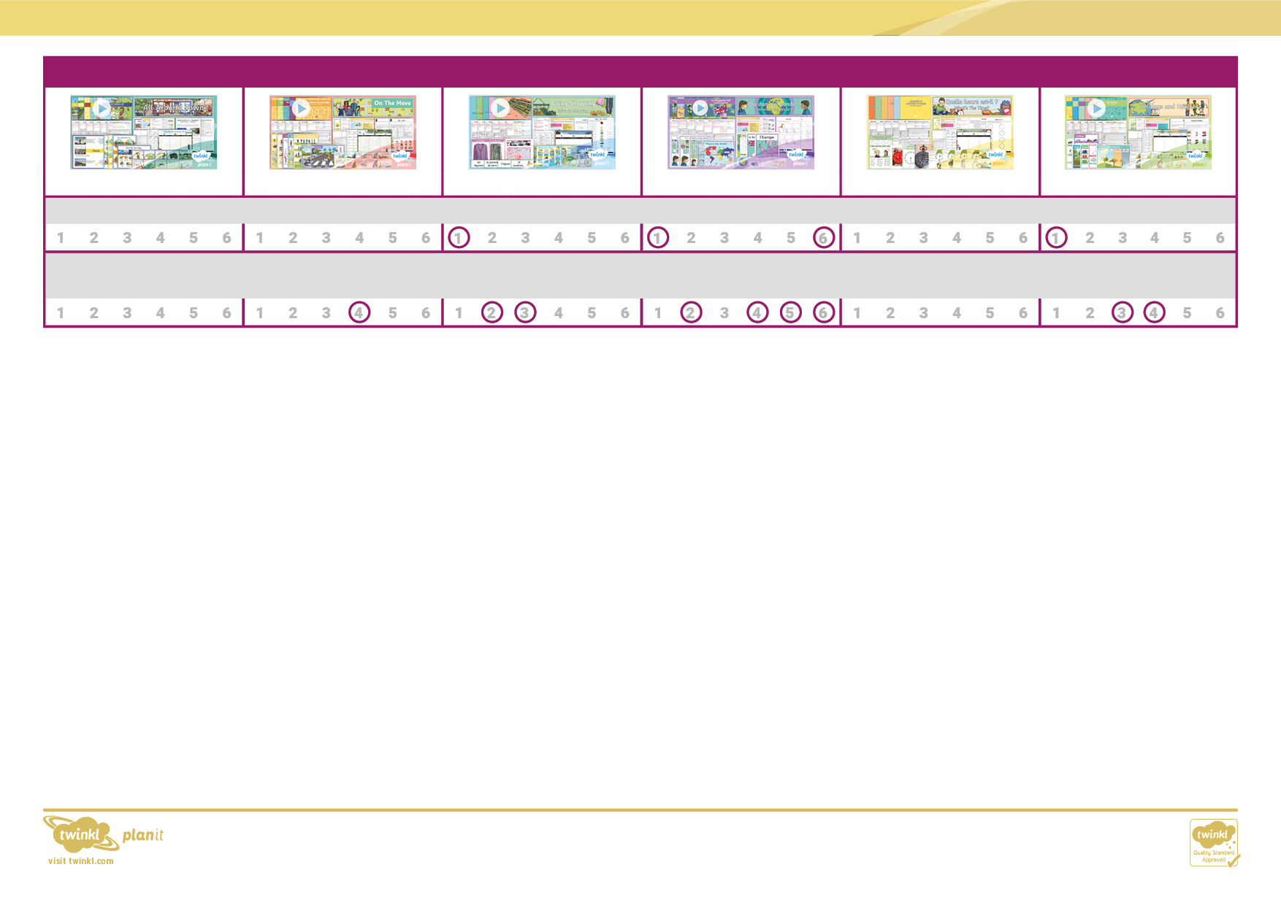

Year 4

French Subject Overview

describe people, places, things and actions orally and in writing

understand basic grammar appropriate to the language being studied, including (where relevant): feminine, masculine and neuter forms and the conjugation of high-frequency verbs; key features and patterns of the language; how to apply these, for instance, to build sentences; and how these differ from or are similar to English

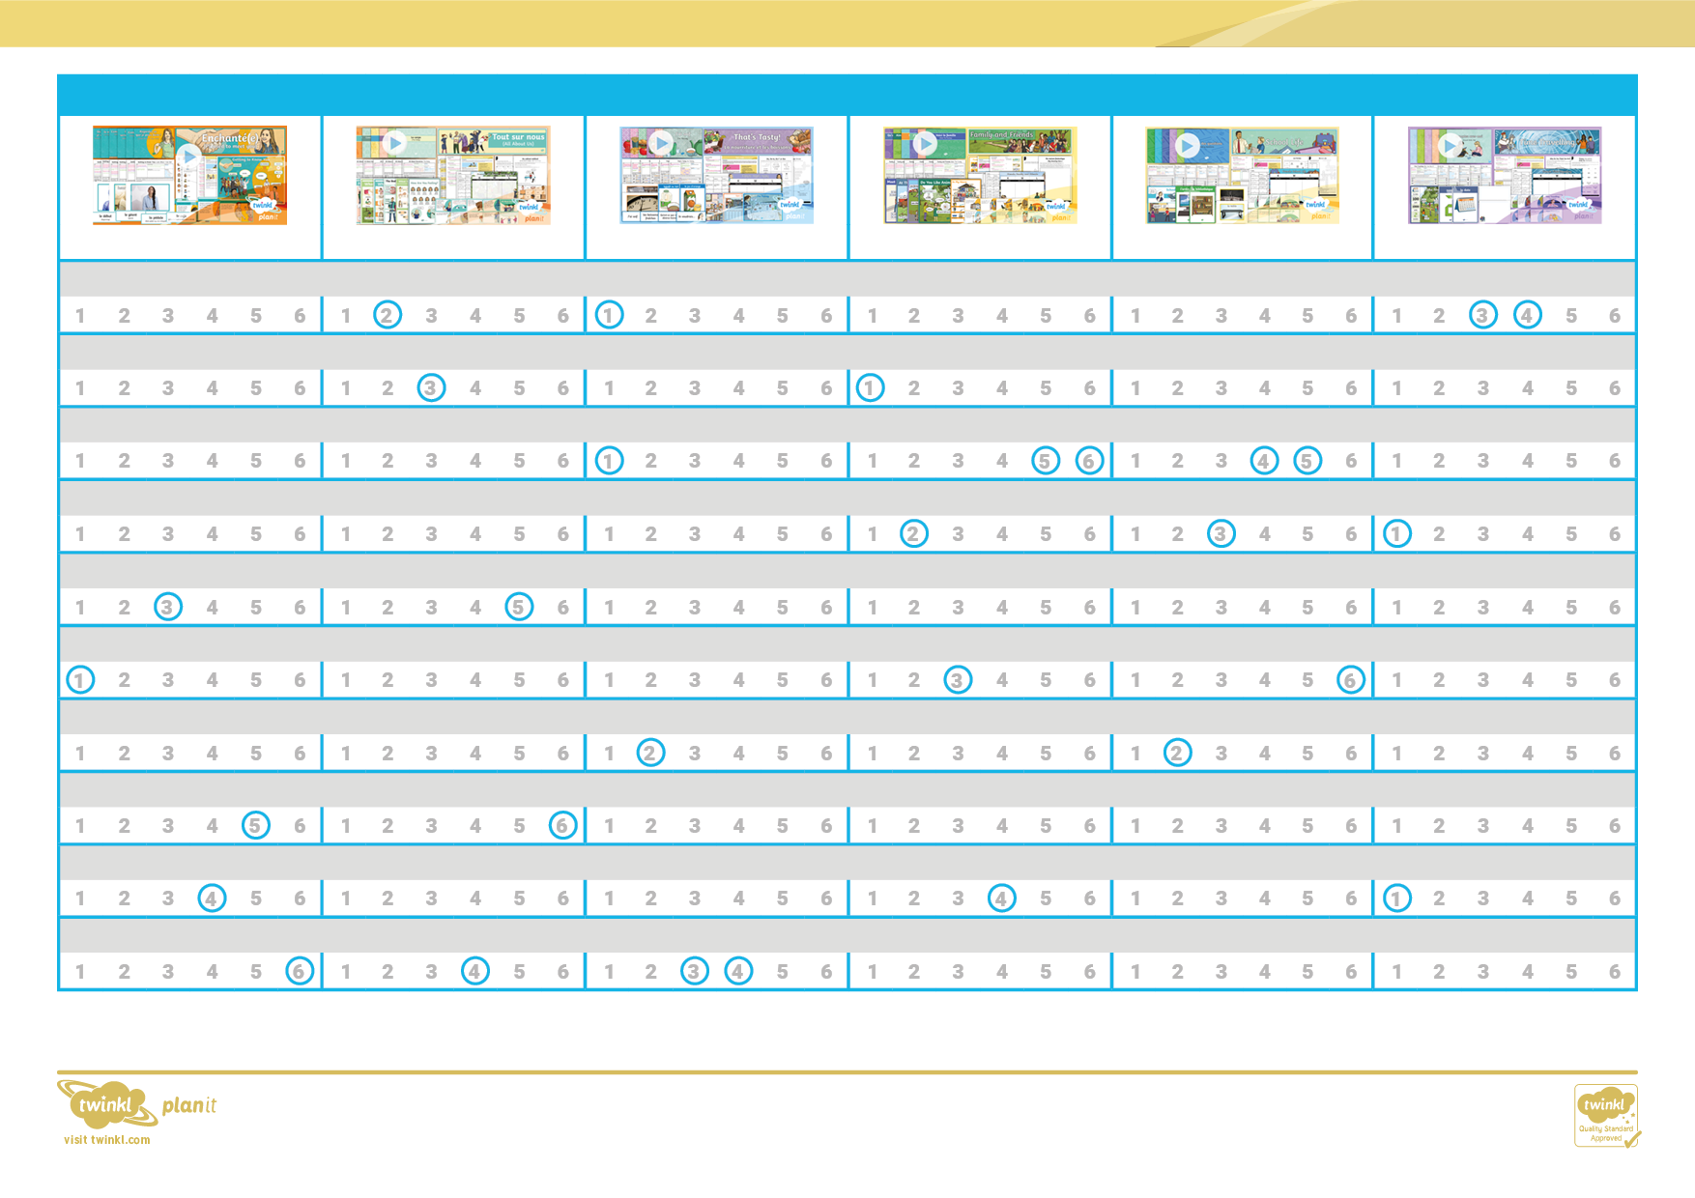

Year 5

French Subject Overview

write phrases from memory, and adapt these to create new sentences, to express ideas clearly

broaden their vocabulary and develop their ability to understand new words that are introduced into familiar written material, including through using a dictionary

appreciate stories, songs, poems and rhymes in the language

read carefully and show understanding of words, phrases and simple writing

present ideas and information orally to a range of audiences

develop accurate pronunciation and intonation so that others understand when they are reading aloud or using familiar words and phrases

speak in sentences, using familiar vocabulary, phrases and basic language structures

engage in conversations; ask and answer questions; express opinions and respond to those of others; seek clarification and help

explore the patterns and sounds of language through songs and rhymes and link the spelling, sound and meaning of words

listen attentively to spoken language and show understanding by joining in and responding

**Time Travelling**

**School Life**

**Family and Friends**

**That's Tasty**

**All About Ourselves**

**Getting to Know You**

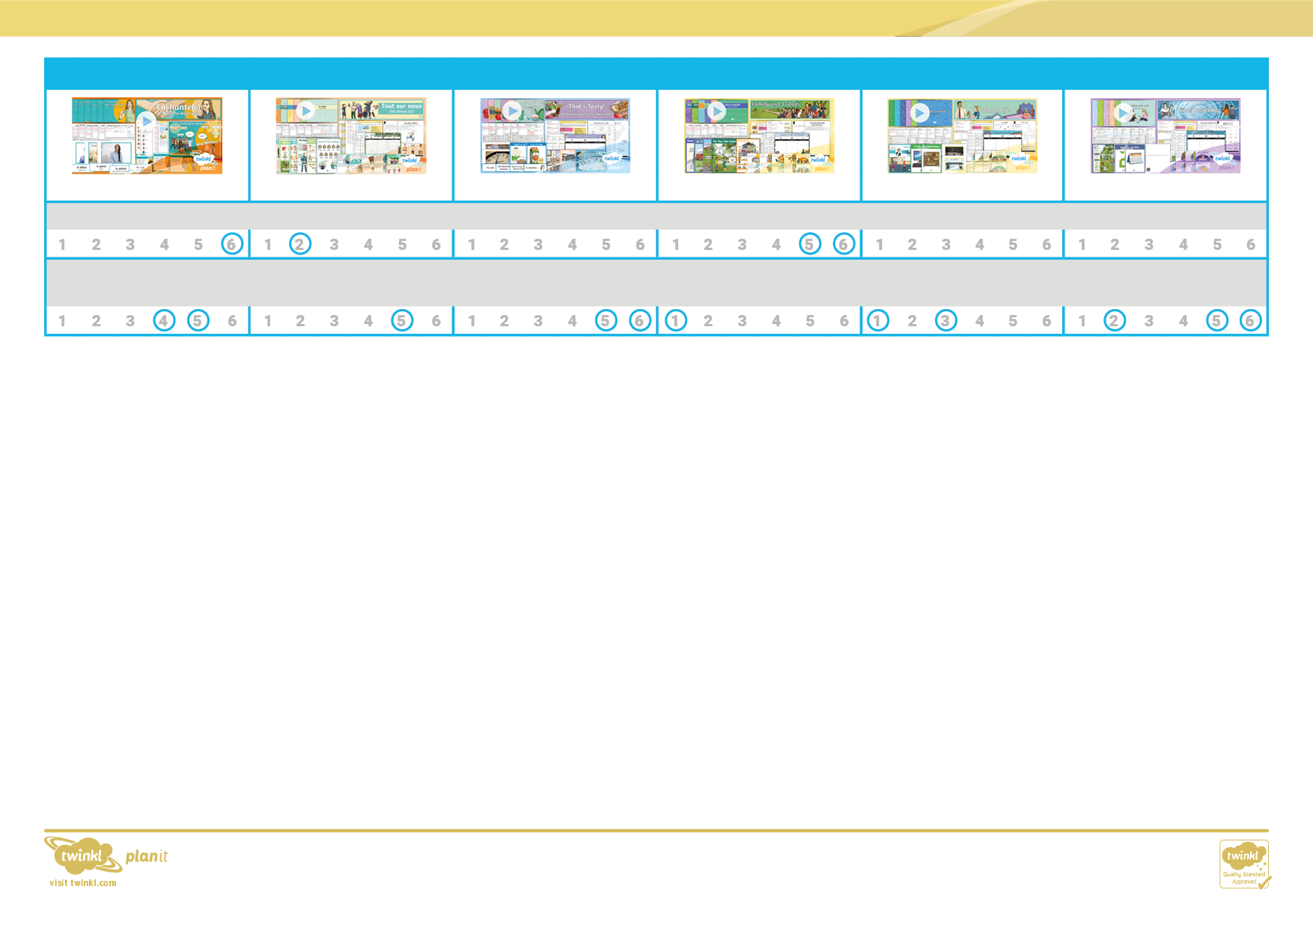

describe people, places, things and actions orally and in writing

understand basic grammar appropriate to the language being studied, including (where relevant): feminine, masculine and neuter forms and the conjugation of high-frequency verbs; key features and patterns of the language; how to apply these, for instance, to build sentences; and how these differ from or are similar to English

French Subject Overview

Year 5

**Time Travelling**

**School Life**

**Family and Friends**

**That's Tasty**

**All About Ourselves**

**Getting to Know You**

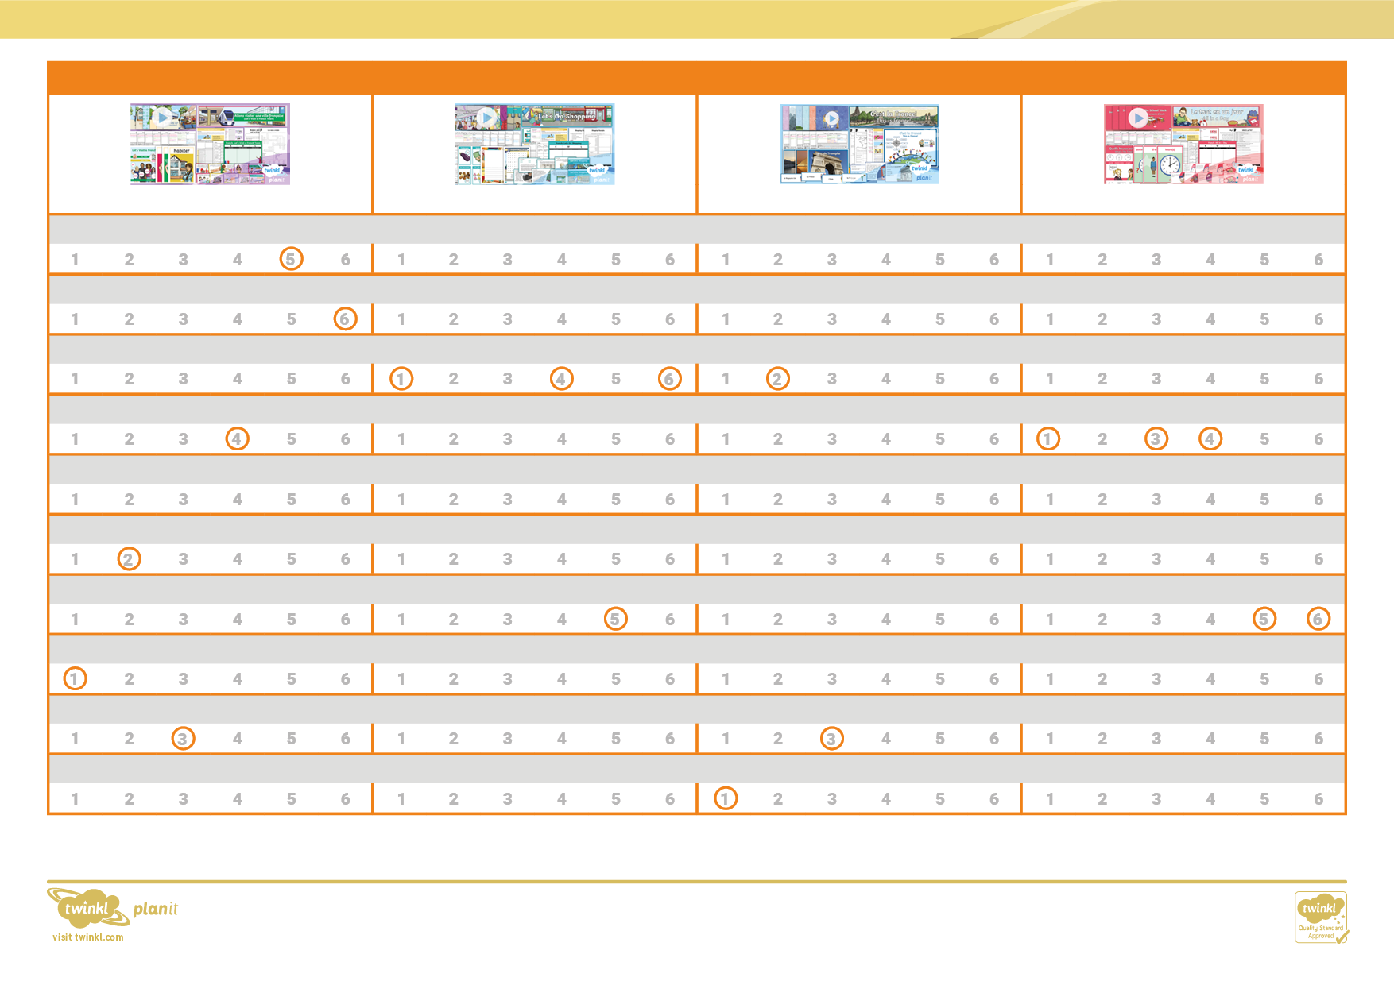

Year 6

listen attentively to spoken language and show understanding by joining in and responding

explore the patterns and sounds of language through songs and rhymes and link the spelling, sound and meaning of words

engage in conversations; ask and answer questions; express opinions and respond to those of others; seek clarification and help

speak in sentences, using familiar vocabulary, phrases and basic language structures

develop accurate pronunciation and intonation so that others understand when they are reading aloud or using familiar words and phrases

present ideas and information orally to a range of audiences

read carefully and show understanding of words, phrases and simple writing

appreciate stories, songs, poems and rhymes in the language

broaden their vocabulary and develop their ability to understand new words that are introduced into familiar written material, including through using a dictionary

write phrases from memory, and adapt these to create new sentences, to express ideas clearly

French Subject Overview

**Let's Visit a French Town**

**Let's Go Shopping**

**This is France**

**All in a Day**

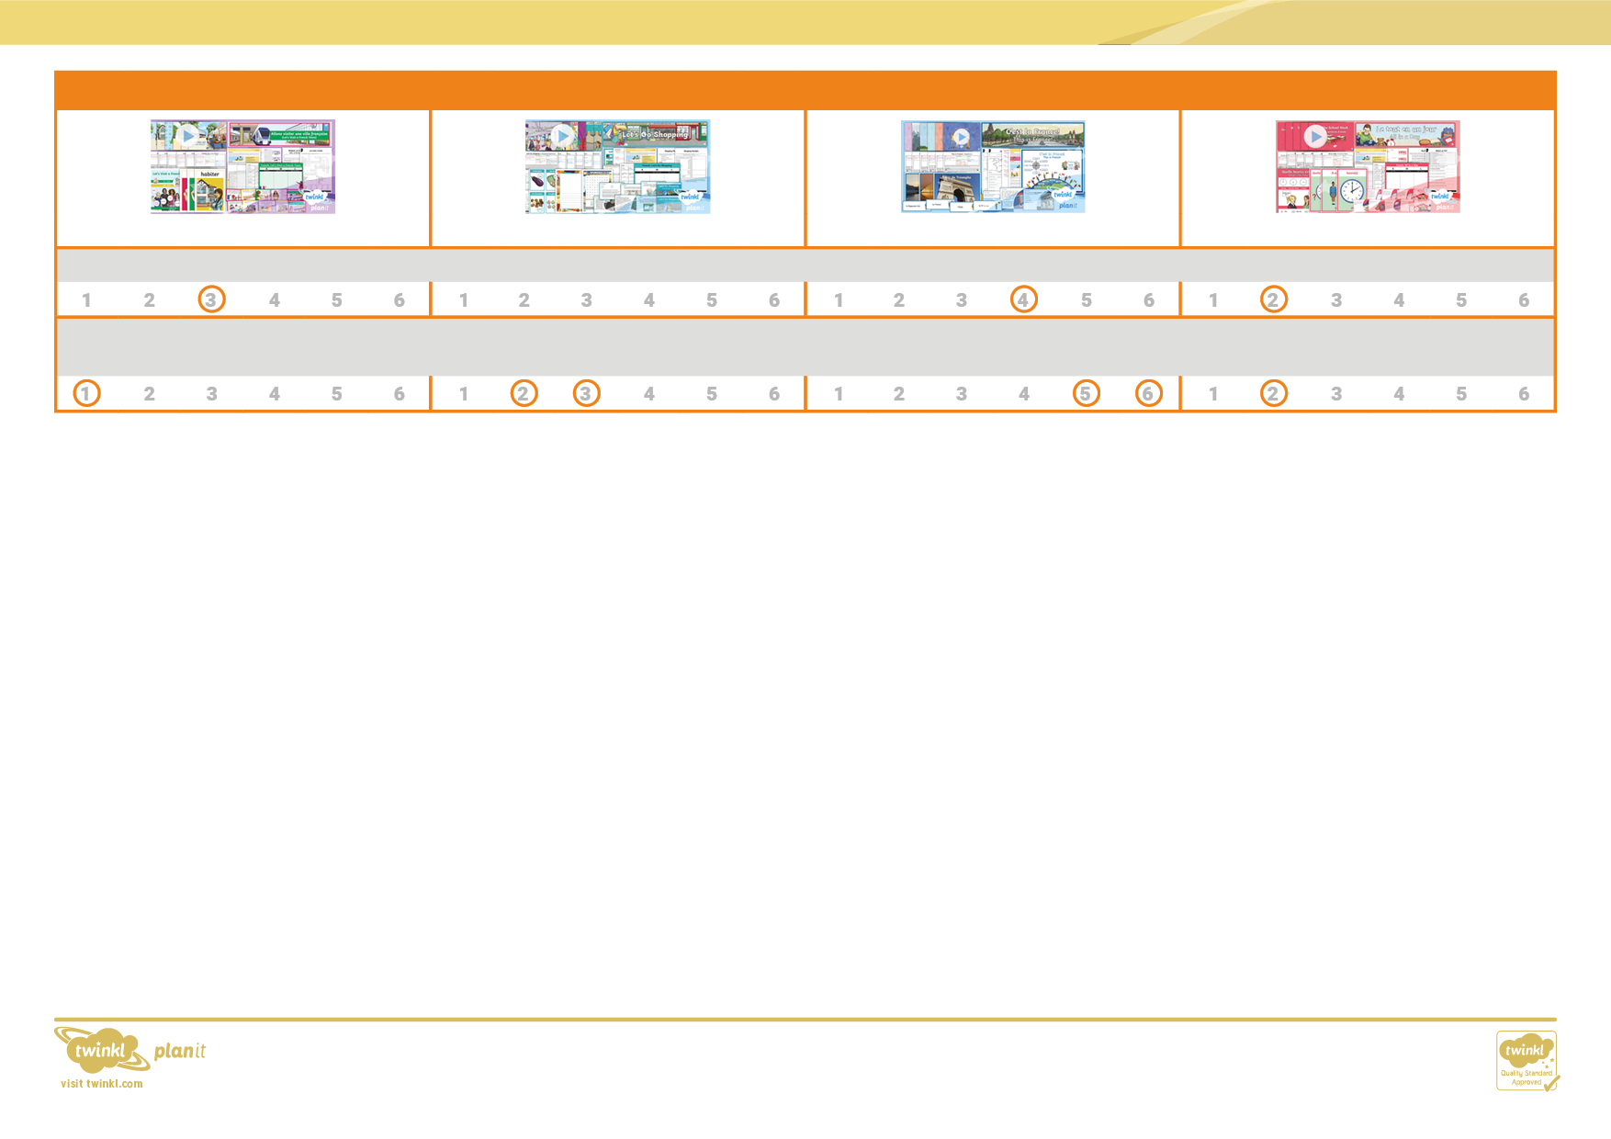

understand basic grammar appropriate to the language being studied, including (where relevant): feminine, masculine and neuter forms and the conjugation of high-frequency verbs; key features and patterns of the language; how to apply these, for instance, to build sentences; and how these differ from or are similar to English

Year 6

**Let's Visit a French Town**

**Let's Go Shopping**

**This is France**

**All in a Day**

describe people, places, things and actions orally and in writing

French Subject Overview